|  |
| --- |
|  |
|  |
| ROTU ARMY UMP: OFFICIAL PORTAL |
|  |
|  |
|  |
|  |
| AHMAD AFIQ AHNAF BIN HARUDIN |
|  |
|  |
|  |
|  |
|  |
|  |
| Bachelor of Computer Science  (Graphic & Multimedia) |
|  |
| UNIVERSITI MALAYSIA PAHANG |
|  |

**SUPERVISOR’s DECLARATION**

I hereby declare that I have checked this thesis and, in my opinion, this thesis is adequate in terms of scope and quality for the award of the degree of Computer Science in Graphic and Multimedia.

_______________________________  
 (Supervisor’s Signature)

Full Name : Dr. Salwana Mohamad @ Asmara

Position : Senior Lecturer

Date : 25 November 2021

**STUDENT’S DECLARATION**

I hereby declare that the work in this thesis is based on my original work except for quotations and citations which have been duly acknowledged. I also declare that it has not been previously or concurrently submitted for any other degree at Universiti Malaysia Pahang or any other institutions.

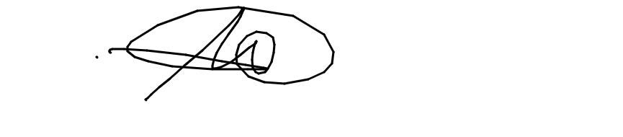

_______________________________  
 (Student’s Signature)

Full Name : Ahmad Afiq Ahnaf Bin Harudin

ID Number : CD19013

Date : 25 November 2021

|  |
| --- |
|  |
|  |
| ROTU ARMY UMP: Official Portal |
|  |
|  |
|  |
|  |
| AHMAD AFIQ AHNAF BIN HARUDIN |
|  |
|  |
| Thesis submitted in fulfilment of the requirements  for the award of the degree of  Bachelor of Computer Science (Graphic & Multimedia) |
|  |
|  |
|  |
|  |
| Faculty of Computing |
| UNIVERSITI MALAYSIA PAHANG |
|  |
| JANUARY 2022 |
|  |
|  |

**ACKNOWLEDGEMENTS**

Firstly, I would like to thank God for the blessings for giving me strength and patience throughout the duration in completing this project report. I am very honoured and grateful to Dr. Salwana Binti Mohamad for being my supervisor. The advice and comment from her are a great contribution for the achievement of my project report. Without her help, it would be difficult for me to complete all the task in this project. Also, I would like to thank to my course mates who kind in sharing knowledge and time to help me with my project report. I really appreciate it.

**ABSTRAK**

Portal ROTU ARMY UMP ialah portal rasmi untuk organisasi ROTU ARMY UMP di Universiti Malaysia Pahang. ROTU ialah singkatan bagi Pasukan Latihan Pegawai Simpanan yang merupakan unit yang melatih pelajar sarjana muda sukarelawan sebagai pegawai simpanan sukarela untuk angkatan tentera Malaysia di Malaysia. Projek ini akan berkongsi dan memaparkan maklumat dan berita penting tentang organisasi ROTU ARMY UMP sahaja.

Sebagai penyataan masalah, pelajar menghadapi masalah untuk mencari maklumat tentang UMP TENTERA ROTU. Selain itu, maklumat tentang ROTU ARMY UMP dalam internet dan Portal UMP terlalu ringkas. Pelajar perlu hadir ke kiosk ROTU ARMY UMP semasa acara suai kenal. Ini akan memakan banyak masa dan menyukarkan pelajar untuk mengetahui sebarang maklumat. Objektif projek adalah untuk mereka bentuk pangkalan data dan Antara Muka Pengguna Grafik untuk Portal ROTU ARMY UMP. Selain itu, projek ini akan difokuskan untuk memaparkan dan menerangkan maklumat mengenai ROTU ARMY UMP untuk pelajar UMP. Projek ini akan dibangunkan untuk mengesahkan pepijat Portal ROTU ARMY UMP.

Skop projek adalah portal hanya menyediakan maklumat dan berita ROTU ARMY UMP yang ditempatkan di Universiti Malaysia Pahang. Selain itu, portal ini memfokuskan kepada pelajar sarjana muda UMP yang menghadapi masalah mencari maklumat mengenai ROTU ARMY UMP sahaja. Portal tersebut memuatkan maklumat dan berita ROTU ARMY UMP seperti pengenalan, sejarah, organisasi, profil, aktiviti, galeri, alumni, dan soalan lazim. Portal ini juga mengandungi bahagian pentadbiran di mana pentadbir boleh mengemas kini dan menyunting maklumat dan berita portal tersebut. Hasil yang diharapkan daripada projek ini adalah portal ini akan memudahkan pencarian maklumat kepada pelajar UMP dan memberi pentadbiran untuk mengemaskini dan menyunting maklumat dan berita tentang organisasi.

Kata kunci—TENTERA ROTU, TENTERA ROTU UMP, pegawai simpanan

**ABSTRACT**

ROTU ARMY UMP Portal is an official portal for ROTU ARMY UMP organization in University Malaysia Pahang. ROTU is stand for Pasukan Latihan Pegawai Simpanan which is a unit that train volunteer undergraduate students as volunteer reserve officers for Malaysian armed force in Malaysia. This project will share and display the important information and news about the ROTU ARMY UMP organization only.

As problem statements, the student is having problem to find the information about the ROTU ARMY UMP. Also, the information about ROTU ARMY UMP in internet and UMP Portal is too concise. The student needs to attend at ROTU ARMY UMP kiosk during orientation event. This will consume much time and making it difficult for students to find out any information. The objective of the project is to design the database and the Graphical User Interface for ROTU ARMY UMP Portal. Also, this project will be focused to display and explaining the information about the ROTU ARMY UMP for the UMP students. This project will be developing to verify bugs of ROTU ARMY UMP Portal.

The scope of the project is the portal only serves ROTU ARMY UMP information and news placed in University Malaysia Pahang. Also, the portal focuses on the UMP undergraduate students who having problem in finding information about the ROTU ARMY UMP only. The portal included the information and news of the ROTU ARMY UMP such as introduction, history, organization, profile, activities, gallery, alumni, and frequently asked questions. The portal also consists of administration section where the admin can update and editing the information and news of the portal. The expected result from this project is this portal will ease the information retrieval to the UMP students and give the administration to update and edit the information and news about the organization.

Keywords—ROTU ARMY, ROTU ARMY UMP, reserve officers

**TABLE OF CONTENT**

**DECLARATION**

**TITLE PAGE**

CHAPTER 1 INTRODUCTION 12

1.1 Introduction 12

1.2 Background of the Problem 13

1.3 Objective 13

1.4 Scope 13

1.5 Thesis Organization 14

CHAPTER 2 LITERATURE REVIEW 15

2.1 Introduction 15

2.2 Three Related Work 15

2.3 Comparative Analysis 18

2.4 Chapter Summary 19

CHAPTER 3 METHODOLOGY 20

3.1 Introduction 20

3.2 Proposed Design & Interface 20

3.3 Hardware & Software Specification 23

3.4 Chapter Summary 24

CHAPTER 4 RESULTS AND DISCUSSION 25

4.1 Introduction 25

4.2 Result 25

4.3 Discussion 39

4.4 Chapter Summary 45

CHAPTER 5 CONCLUSION 46

5.1 Objective Revisited 46

5.2 Limitation 47

5.3 Future Work 48

**LIST OF TABLES**

|  |  |  |
| --- | --- | --- |
| Table 2.1 | Specification of existing portal | 15 |
| Table 2.2 | Advantage & Disadvantage of existing portal | 17 |
| Table 3.1 | Software used for the project | 21 |
| Table 3.2 | Hardware used for the project | 21 |
| Table 4.1 | User Acceptance Test Form for User | 38 |
| Table 4.2 | User Acceptance Test Form for Admin | 39 |
| Table 4.3 | User Acceptance Test Form for Staff | 40 |
| Table 4.4 | User Acceptance Test Form for Current Intake | 41 |
| Table 4.5 | User Acceptance Test Form for New Intake | 42 |
| Table 7.1 | Home Page of ROTU ARMY UMP Portal | 56 |
| Table 7.2 | Login Page of ROTU ARMY UMP Portal | 57 |
| Table 7.3 | Frequently Asked Question Page of ROTU ARMY UMP Portal | 58 |
| Table 7.4 | New Intake Registry Page of ROTU ARMY UMP Portal | 59 |
| Table 7.5 | About Us Page of ROTU ARMY UMP Portal | 60 |
| Table 7.6 | Organization Chart Page of ROTU ARMY UMP Portal | 61 |
| Table 7.7 | Contact Us Page of ROTU ARMY UMP Portal | 62 |
| Table 7.8 | Admin FAQ Page of ROTU ARMY UMP Portal | 63 |
| Table 7.9 | News Page of ROTU ARMY UMP Portal | 64 |
| Table 7.10 | New Intake List Page of ROTU ARMY UMP Portal | 65 |
| Table 7.11 | New Intake Information Page of ROTU ARMY UMP Portal | 66 |
| Table 7.12 | Upload Syllabus File Page of ROTU ARMY UMP Portal | 67 |
| Table 7.13 | Syllabus Download List Page of ROTU ARMY UMP Portal | 68 |

**LIST OF FIGURES**

|  |  |  |
| --- | --- | --- |
| Figure 4.1 | Home page | 26 |
| Figure 4.2 | About Us page | 27 |
| Figure 4.3 | Organization Chart page | 28 |
| Figure 4.4 | News page | 29 |
| Figure 4.5 | Frequently Asked Question page | 30 |
| Figure 4.6 | Contact Us page | 30 |
| Figure 4.7 | Navigation tab for public user page | 31 |
| Figure 4.8 | Login page | 31 |
| Figure 4.9 | New Intake Registry page | 32 |
| Figure 4.10 | User Frequently Asked Question for Admin page | 33 |
| Figure 4.11 | Update Frequently Asked Question for Admin page | 33 |
| Figure 4.12 | Navigation Tab for Admin page | 34 |
| Figure 4.13 | Navigation Tab for Staff page | 34 |
| Figure 4.14 | New Intake Information for Staff page | 35 |
| Figure 4.15 | Update New Intake Information for Staff page | 36 |
| Figure 4.16 | New Intake List for Staff page | 37 |
| Figure 4.17 | Upload Syllabus File for Staff page | 37 |
| Figure 4.18 | Syllabus Download List for Current Intake page | 38 |
| Figure 4.19 | Navigation Tab for Current Intake page | 38 |

**LIST OF APPENDICES**

|  |  |  |
| --- | --- | --- |
| Appendices A | Flowchart of ROTU ARMY UMP Portal | 49 |
| Appendices B | Context Diagram of ROTU ARMY UMP Portal | 56 |
| Appendices C | Use Case Diagram of ROTU ARMY UMP Portal | 57 |
| Appendices D | Storyboard of ROTU ARMY UMP Portal | 58 |
| Appendices E | Test Result | 71 |
|  |  |  |
|  |  |  |
|  |  |  |
|  |  |  |
|  |  |  |
|  |  |  |
|  |  |  |
|  |  |  |
|  |  |  |
|  |  |  |
|  |  |  |
|  |  |  |
|  |  |  |
|  |  |  |

# INTRODUCTION

## Introduction

ROTU ARMY UMP Portal is an authority entrance for ROTU ARMY UMP association in University Malaysia Pahang. ROTU is represent Pasukan Latihan Pegawai Simpanan which is a unit that train volunteer college understudies as volunteer reserve officers for Malaysian equipped power in Malaysia. ROTU ARMY UMP Official Portal is a portal that shared all the information about the organization. There is existing portal which manage the ROTU ARMY organization from public universities such as UNIMAS, UM and UPM.

This portal consists of some pages such the Home, Login, New Intake Registry, Frequently Asked Question, About Us, Organization Chart, Contact Us and News Pages for public user. For the admin, the page related such as User Frequently Asked Question which they can answer the user question. Then, for the staff, page relate such as New Intake Information, New Intake List and Upload Syllabus File. Also, for the current intake, the page relates include the Syllabus Download List. With this project development, the efficiency in delivering the information will increase rapidly to the students especially. The information of ROTU ARMY UMP can be found in this portal without searching for any other portal, directly go to the ROTU ARMY UMP office or contact to the administration. This will consume time taken for the student to receive any information about it.

Additionally, this portal development will be focused to show and clarifying the data about the ROTU ARMY UMP for the UMP understudies. This task will be creating to confirm bugs of ROTU ARMY UMP Portal. The extent of the portal is the entryway just serves ROTU ARMY UMP data and news put in University Malaysia Pahang. Likewise, the project focuses on the UMP understudies who having issue in discovering data about the ROTU ARMY UMP as it were.

## Background of the Problem

1. They are having issue in finding and get the information about the organization because they need to attend the ROTU ARMY UMP kiosk during the orientation event only.
2. The information about the ROTU ARMY UMP in official UMP Portal or in internet is too concise.

## Objective

1. To design a ROTU ARMY UMP Portal system.
2. To develop a portal that display and explaining the information and news about the ROTU ARMY UMP for the UMP students.
3. To develop a portal that ease the student and staff to manage the ROTU ARMY UMP organization.
4. To verify bugs of the ROTU ARMY UMP Portal.

## Scope

1. The portal only serves ROTU ARMY UMP information and news placed in University Malaysia Pahang.
2. The portal focuses on the UMP undergraduate students who having problem in finding information about the ROTU ARMY UMP only.
3. The portal includes five user which is admin, staffs, current student, public user and new students.

## Thesis Organization

First and foremost, Chapter 1 explains about the introduction of the ROTU Army UMP Portal. Also, the background of the problem and the objective consist in this thesis. The scope of the thesis explained to find specific requirement to develop this system.

For Chapter 2, the content explained about the literature review of the thesis. The information includes introduction of Chapter 2, three related work, comparative analysis, and chapter summary. Three related works explained about three existing system related to the thesis. The comparative analysis consists with the advantage and disadvantage of the existing systems.

Next, Chapter 3 explained about the thesis methodology. First, the explanation about the proposed design and interface which consist of the portal flowchart, context diagram, use case diagram, and storyboard. Also, the hardware and software specification will be present in this thesis. Then, the chapter summary for Chapter 3.

In Chapter 4, the main title is results and discussion. The first point is about the introduction of this chapter. The result will be conducted by testing the portal. Also, the discussion from the result explained to improve the portal for better result. The explanation about the chapter summary of Chapter 4 also included.

Finally, the final chapter which is Chapter 5 will explain about the conclusion of this thesis. The content includes the objective revisited which the portal meets the objective of the thesis. Then explanation about the limitation during completing this thesis and portal. Also, the future work that discuss about the enhancement that can be improve from the portal for better result.

# LITERATURE REVIEW

## Introduction

For Chapter 2, the content explained about the literature review of the thesis. The information includes introduction of Chapter 2, three related work, comparative analysis, and chapter summary. Three related works explained about three existing system related to the thesis. The comparative analysis consists with the advantage and disadvantage of the existing systems.

## Three Related Work

ROTU UNIMAS portal is a system that serve the information of ROTU ARMY and Udara to the student and staff. This portal is used by student and staff from University Malaysia Sarawak. The public user also can visit this open portal. The average age that suitable to visit this portal range 18-year-old above especially for the first-year student. This portal is developed using bootstrap template from another bootstrap website. The user interface and functionality are developed by using HTML, JavaScript, and CSS programming languages. Also, the use of Google API in this portal can be seen in the sitemap. The data is stored in UNIMAS Datastore and MySQL for the database. The use of password-based authentication for login credentials. The server also is use from UNIMAS server to avoid anonymous or any ransomware attacking the portal. Also, the data and the portal can be controlled by the UNIMAS only. All the data will be store safely to secure the privacy. The portal is deployed in UNIMAS Official Portal, Google, Facebook, Twitter, YouTube, and Flickr. For any information or question can visit the official portal at http://www.ROTU.unimas.my/.

ROTU UPM portal is a framework that serve the data of ROTU ARMY just to the understudy and staff. This entrance is utilized by understudy and staff from University Putra Malaysia. The public client likewise can visit this open entrance. The normal age that reasonable to visit this entrance range 18-year-old above particularly for the main year understudy. This entrance is created utilizing own plan format. The UI and usefulness are created by utilizing HTML, JavaScript, and CSS programming dialects. Additionally, the utilization of Google API in this gateway can be found in the sitemap. The information is put away in UPM Datastore and Oracle for the data set. The administrator mindful in dealing with the data in the gateway. The worker likewise is use from UPM worker to keep away from unknown or any ransomware assaulting the entry. Likewise, the information and the entrance can be constrained by the UPM as it were. All the information will be store securely to get the protection. The entrance is sent in UPM Official Portal, Google, Facebook, Twitter, YouTube, and Instagram. For any data or question can visit the authority gateway at https://ROTU.upm.edu.my/.

ROTU UM portal is a system that serve the information of ROTU ARMY and Navy to the understudy and staff. This entrance is used by understudy and staff from University Malaya. The public user furthermore can visit this open passageway. The typical age that sensible to visit this section range 18-year-old above especially for the essential year understudy. This section is made using bootstrap format from Probootsrap. The UI and helpfulness are made by using HTML, JavaScript, and CSS programming lingos. Moreover, the use of Google API in this door can be found in the sitemap. The data is taken care of in UM Datastore and PostgreSQL for the informational collection. The admin fit in managing the information in the passageway. The laborer moreover is use from UM specialist to avoid obscure or any ransomware attacking the doorway. Moreover, the data and the passage can be compelled by the UM figuratively speaking. All the data will be store safely to get the security. The doorway is passed on in UM Official Portal, Google, Facebook, Twitter, YouTube, and Instagram. For any information or question can visit the position entrance at https://ROTU.um.edu.my/record. Table 2.1 shows the summary of the specification existing systems.

Table 2.1 – Specification of existing portal

|  |  |  |  |
| --- | --- | --- | --- |
| SPECIFICATION | ROTU UNIMAS | ROTU UPM | ROTU  UM |
| User | -Student and staff from University Malaysia Sarawak  -Average age 18 above | -Student and staff from University Putra Malaysia  -Average age 18 above | -Student and staff from University Malaya  -Average age 18 above |
| Interface | -Develop using bootstrap template from another bootstrap website  -Using HTML, JavaScript, and CSS programming languages  -Google API for sitemap | -Develop using own design template  -Using HTML5, JavaScript and CSS programming language  -Using Google API link for sitemap | -Develop using bootstrap template from Probootsrap  -Using HTML, JavaScript, and CSS programming language  -Using Google API for location |
| Database | -UNIMAS Datastore  -MySQL Database | -UPM Datastore  -Oracle Database | -UM Datastore  -PostgreSQL Database |
| Security | -Password based authentication for login  -UNIMAS server | -Information controlled by the admin only  -UPM server | -Information controlled by the admin only  -UM server |
| Deployment | -UNIMAS Official Portal  -Google  -Facebook  -Twitter  -YouTube  -Flickr | -UPM Official Portal  -Google  -Facebook  -Twitter  -YouTube  -Instagram | -UM Official Portal  -Google  -Facebook  -Twitter  -YouTube  -Instagram |
| Unit Involved | -ROTU ARMY  -ROTU Udara | -ROTU ARMY | -ROTU ARMY  -ROTU Navy |
| Website link | http://www.ROTU.unimas.my/ | https://ROTU.upm.edu.my/ | https://ROTU.um.edu.my/index |

## Comparative Analysis

At the previous section, the ROTU UNIMAS Portal is a system that serve the information of ROTU ARMY and Udara to the student and staff. The first advantage can be seen in this portal is the portal has a compatible and attractive Graphical User Interface. The arrangement of the information section and the related buttons section is neat and tidy which ease the user to read and find the information given. The Interface also look modern and elegant which follow the recent trend design. The second advantage of the portal is it has Question and Answer page. The user can view all the previous information that have been asked related to the ROTU UNIMAS. The user also can contact the admin by fill the contact form if having any question to ask to them. Apart from that, this portal also has several disadvantages. Firstly, the login page does not function and has error page. By clicking the login button, the system will display back the home page rather than proceed to the login form page. Secondly, the disadvantage of the portal is the Quick Links button also does not function. If the user clicking the button, it will proceed to the error page which show 404 error, page not found.

For the next portal, the ROTU UPM Portal which a framework that serve the data of ROTU ARMY just to the understudy and staff. This portal has come with some benefits which this portal has downloaded documents page. The user can download the documents because all the documents can be share publicly. Then, the portal has included the related link for other websites such as Tentera ARMY Malaysia Portal, UPM Official Portal and others. This links will ease the user to go and find the future jobs information which related to the army occupation. Besides that, the disadvantage for this portal the home interface is too crowded. The interface has less iconography which icon for the buttons is important to ease the user to memorize the icon function rather than texts. The second disadvantage is it has unremoved ADs. With this issue, the view in this portal will be distracted with unknown ads. If the user suddenly clicking the ads, it will open the unknown website which unsecure to the user devices. Also, having ads is not suitable for the formal portal.

Moreover, the ROTU UM Portal role as a system that serve the information of ROTU ARMY and Navy to the understudy and staff. This portal has some advantages which is the portal has News page about the activities related to the Unit. The admin will update the recent news that have been held by the ROTU UM. Then, the portal has full and concise information about their High Commandants. The information includes the rank, office contact number, office fax number, and email. Also, the portal has its disadvantages such as the Social Media buttons does not fully function. There only one social media button that function which is Facebook page button. If the user clicking the Facebook button, it will proceed to the Official ROTU UM Facebook page. The other social media button doe does not function such as Twitter, Instagram, and YouTube buttons. If the user clicks that button, it will constantly go to the previous page. Table 2.2 show the summary of the specification of the existing systems includes their advantages and the disadvantages.

Table 2.2 – Advantage & Disadvantage of existing portal

|  |  |  |
| --- | --- | --- |
| System | Advantage | Disadvantage |
| ROTU UNIMAS | - Graphical User Interface compatible and attractive | - Login page does not function and error |
| - Has Question and Answer page | - Quick Links button not function |
| ROTU UPM | - Has public share downloaded documents | - The home interface too crowded |
| - Include related link for other websites | - Has unremoved ADs |
| ROTU UM | - Has News page about activities related to the Unit | - Social Media button does not function |
| - Has full and concise information about their High Commandants | - Graphical User Interface too simple and less information provided |

## Chapter Summary

For Chapter 2, the content discusses about the literature review of the thesis. The chapter includes the introduction of Chapter 2, three related work, comparative analysis, and chapter summary. Three related works explained about three existing system related to the thesis. The comparative analysis consists with the advantage and disadvantage of the existing systems. For the next chapter, which is Chapter 3, will explained about the methodology of the thesis.

# METHODOLOGY

## Introduction

Chapter 3 explained about the thesis methodology. First, the explanation about the proposed design and interface which consist of the portal flowchart, context diagram, use case diagram, and storyboard. Also, the hardware and software specification will be present in this thesis. Then, the chapter summary for Chapter 3.

## Proposed Design & Interface

1. Flow chart

In this project, the flowchart will be designed to show the process of the ROTU ARMY UMP Portal occur. In APPENDIX A, the flowchart of the ROTU ARMY UMP Portal illustrated overall process of the portal.

Based on the APPENDIX A, the flowchart of the ROTU ARMY UMP is shown from Figure 7.1 until Figure 7.14. Generally, the flow begins with the Home , Login, New Intake Registry, Frequently Asked Question, About Us, Organization Chart, Contact Us and News Pages for public user. For the admin, the page related such as User Frequently Asked Question which they can answer the user question. Then, for the staff, page relate such as New Intake Information, New Intake List and Upload Syllabus File. Also, for the current intake, the page relates include the Syllabus Download List.

1. Context Diagram

In this project, the use of the Context Diagram is important to illustrate the simple flow between the system and the user. Refer in APPENDIX B, the Context Diagram of this system will be shown in Figure 7.11.

Based on the Context Diagram in APPENDIX B, the developer will develop the full complete ROTU ARMY UMP Portal and the portal will be test by the user. The portal will display and give the information related the organization. The user will view and get all the information from the portal. If the user has any question about the organization, the user can contact the admin by fill the contact form given in the portal as communication medium.

The admin, staff and current intake can login into the internal portal by entering the username and password. Also, they need to choose type of user and clicking the submit button.

The staff can view all the new intake information and can update it. Also, they can delete the information. The staff can upload any syllabus files to the current intake views and downloaded.

For admin, they can view and answer all the public user question. The public user also can view their answer in the Frequently Asked Question page. For the new intake, they can fill the registration application form and will be review by the staff for next procedure.

1. Use Case Diagram

Use Case Diagram is used in this project to give visual representation of potential interaction by the user between the portal. In APPENDIX C, there will show the Use Case Diagram of this project.

Based on the Use Case Diagram in APPENDIX C, the new intake student needs to fill the registration form. They need to enter all require information and clicking the submit button. The information will be proceeded to the database and will received to the staff. The staff can view all the information and can edit the data. Also, they can delete each of the information.

The current intake can login to the login form to enter the internal portal. They need to fill the required data to approve entering it. Also, the staff and admin need to fill the login for to enter their internal portal page.

The public user needs to fill the contact us for if they want to ask any question related to the organization or the portal. All the related information will be sent to the admin to be referred and answered. The admin will receive the information and can answer the public user question and the answer will be display at the FAQ page.

The staff can upload any file related the syllabus of the organization. They can view all the recorded file and delete it. The current intake student will receive the uploaded file and they can view the files. Also, they can download the files.

1. Storyboard

The storyboard is including in this project to illustrate the storyline flow and the wireframe of the project. Refer in APPENDIX D, the storyboard of the ROTU ARMY UMP Portal will be explain through each screen include the screen title, layout, screen layout, and description.

Based on the storyboard in the APPENDIX D, the wireframe of each page has been attaching from Table 7.1 until 7.13. The storyboard will include some information about each page such as the Screen Title, Layout, Screen Layout, and Description.

## Hardware & Software Specification

In this proposed project, there is use of software and hardware requirements. Table 3.1 shows the list of the software tools that use in this project. Table 3.2 shows the list of the hardware tools that use to complete this project.

Table 3.1 – Software used for the project

|  |  |
| --- | --- |
| Software | Description |
| Visual Studio Code | To write the programming languages to design interface and develop the full project. |
| XAMPP | To integrate with the suitable server to load and test the project system. |
| Draw.io | To design the flowchart, storyboard, Use Case Diagram and Context Diagram of the project. |
| Microsoft PowerPoint | To create slide for the presentation of project |
| Microsoft Word | To write the project report |
| Google Chrome | To find the reference for the project |

Table 3.2 – Hardware used for the project

|  |  |  |
| --- | --- | --- |
| Hardware | Specification | Description |
| Personal Laptop | - Window 10 Pro  - Intel(R) Core (TM) i7-5500U CPU @ 2.40GHz 2.40 GHz Processor  - 4.00 GB RAM  - 64-Bit Operating System | To run the system and write the documentation and program languages. |
| Samsung External Hardisk (HDD) | - Samsung  - 1TB | To store data and back up it |
| iPhone 6 | - iOS 12.5  - 4.00 GB RAM  - 125 GB Storage | To record and edit the presentation video. |

## Chapter Summary

Chapter 3 discuss about the thesis methodology. First, the explanation about the proposed design and interface which consist of the portal flowchart, context diagram, use case diagram, and storyboard. Also, the hardware and software specification will be present in this thesis. Then, the chapter summary for Chapter 3. For the next chapter which is Chapter 4 will explain about the result and discussion.

# RESULTS AND DISCUSSION

## Introduction

In Chapter 4, the main title is results and discussion. The first point is about the introduction of this chapter. The result will be conducted by testing the portal. Also, the discussion from the result explained to improve the portal for better result. The explanation about the chapter summary of Chapter 4 also included.

## Result

For this section, the explanation about the user interface that have been done during the development in the figures below. The whole development of the ROTU ARMY UMP succeed meet the requirement and will manage the organization information securely.

Figure 4.1 shows the interface of the Home page for ROTU ARMY UMP. The interface consists of several information such as historic information, latest annual camp video, newest activities that have been conducted and the site map for the main office of the organization.

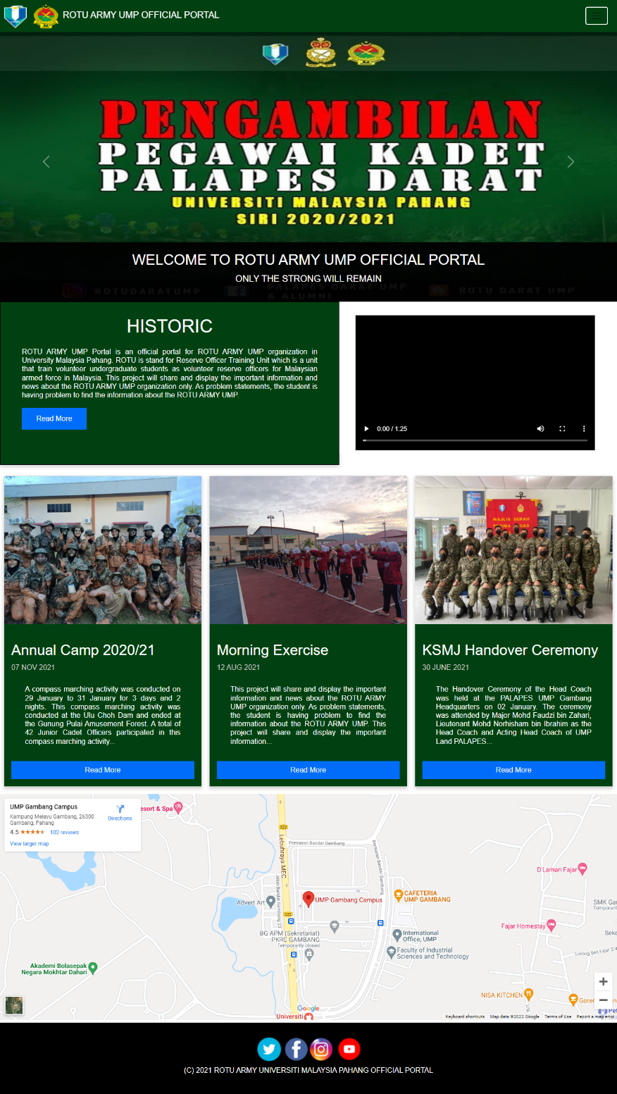

Figure 4.1 Home page

Figure 4.2 shows the About Us page for ROTU ARMY UMP. The interface has some related information such as Commandant foreword, Historic of the organization, and Ikrar Kesatria.

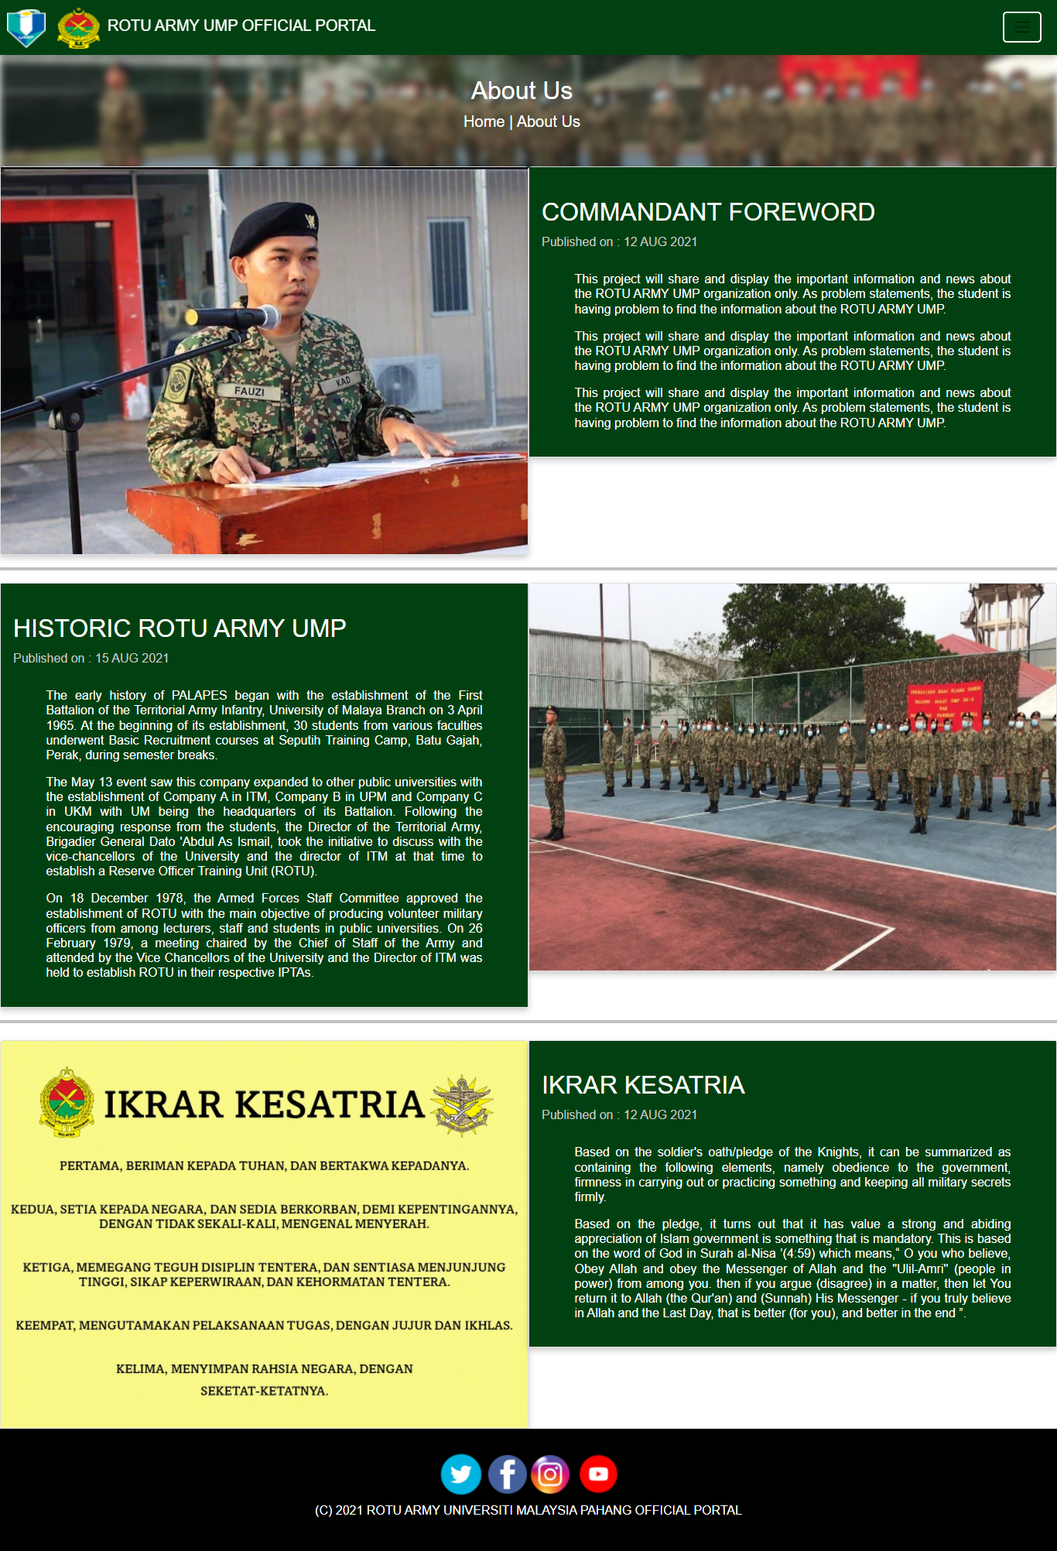

Figure 4.2 About Us page

Figure 4.3 shows the Organization Chart page for ROTU ARMY UMP. The information includes such as ROTU ARMY UMP Officer and staff, First Batch Intake, Second Batch Intake, Third Batch Intake, and Forth Batch Intake.

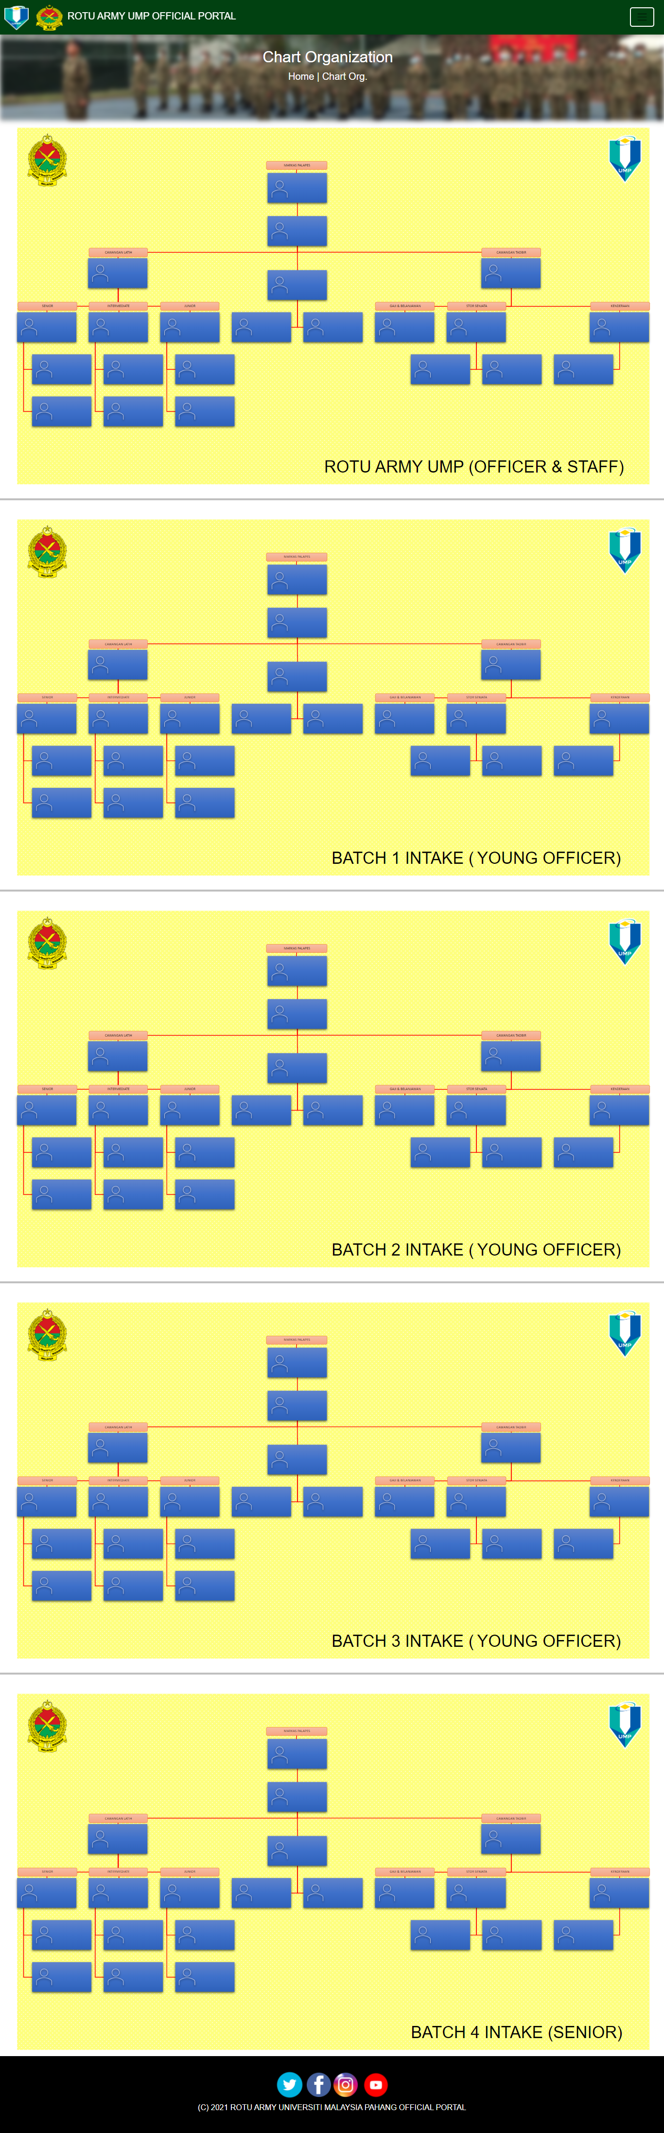

Figure 4.3 Organization Chart page

Figure 4.4 shows the news page for ROTU ARMY UMP. There is several news such the Annual Camp 2020/2021, Morning Exercise and KSMJ Handover Ceremony.

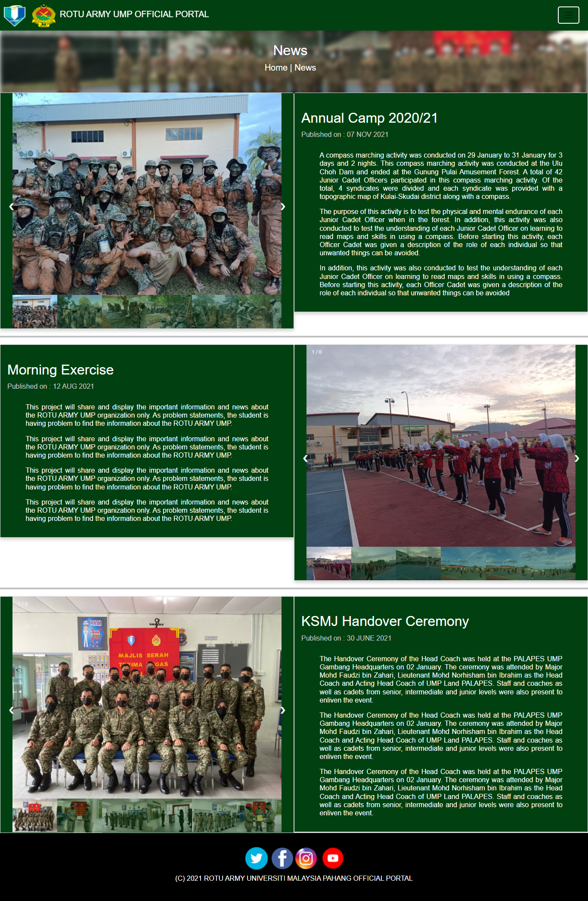

Figure 4.4 News page

Figure 4.5 shows the Frequently Asked Question page of ROTU ARMY UMP. In this page, it will show the user question and the admin response or answer as below.

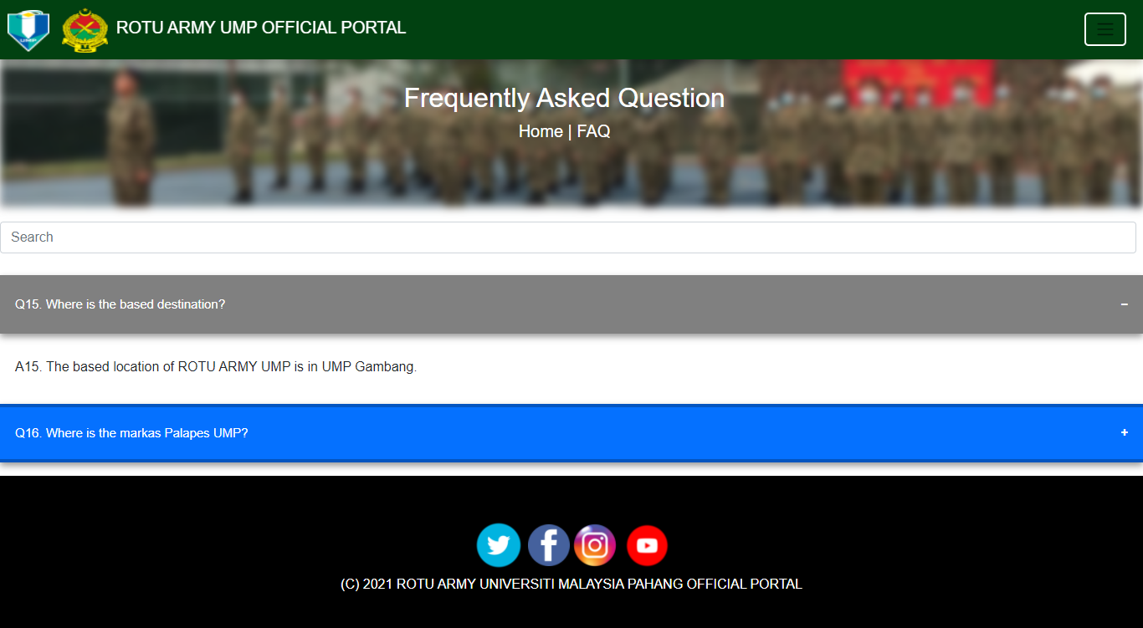

Figure 4.5 Frequently Asked Question page

Figure 4.6 shows the Contact Us page for ROTU ARMY UMP. This page contains information attached and a form for the user asking any question related to the organization.

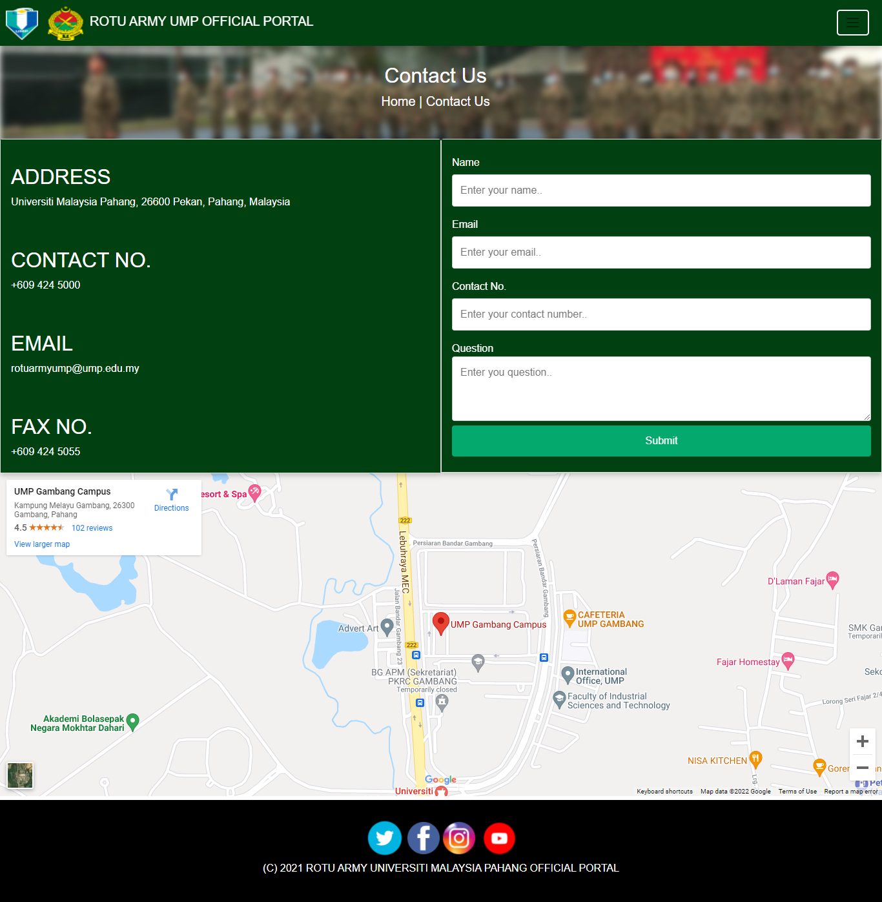

Figure 4.6 Contact Us page

Figure 4.7 shows the navigation tab for public user. The tabs include Home, About Us, Chart Organization, News, Frequently Asked Question and Contact Us.

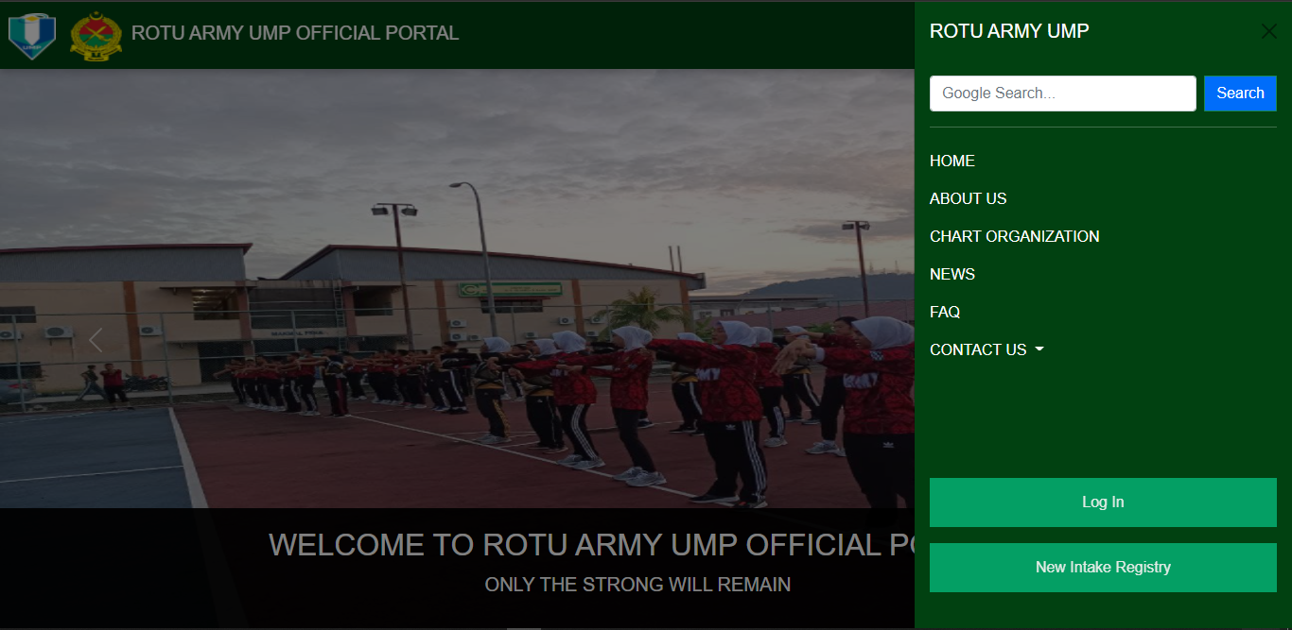

Figure 4.7 Navigation tab for public user page

Figure 4.8 shows the Login page of ROTU ARMY UMP. The user includes staff, admin, or current intake need to login to enter their main page.

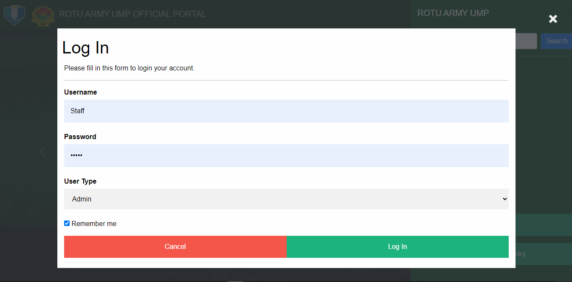

Figure 4.8 Login page

Figure 4.9 shows the New Intake Registry page of ROTU ARMY UMP. The new applicant can apply the registration application through here by filling required information.

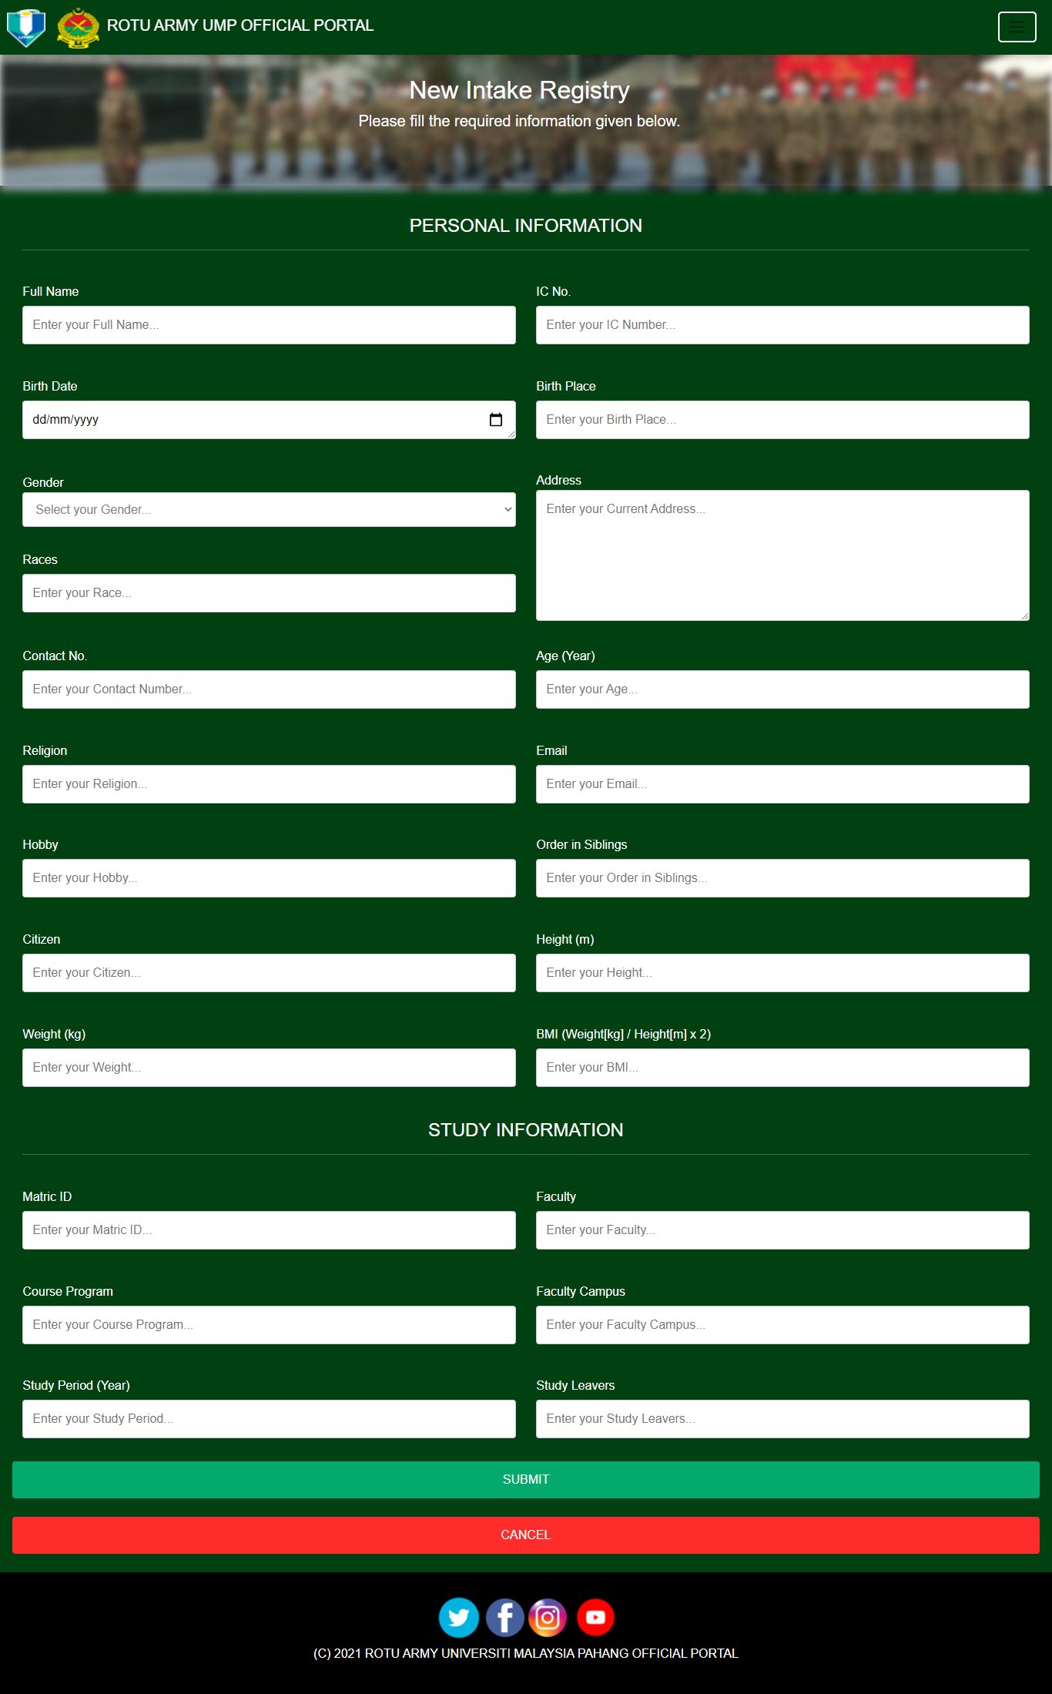

Figure 4.9 New Intake Registry page

Figure 4.10 shows the User Frequently Asked Question for Admin page. The admin can view all user question and can answer it by clicking the Edit button.

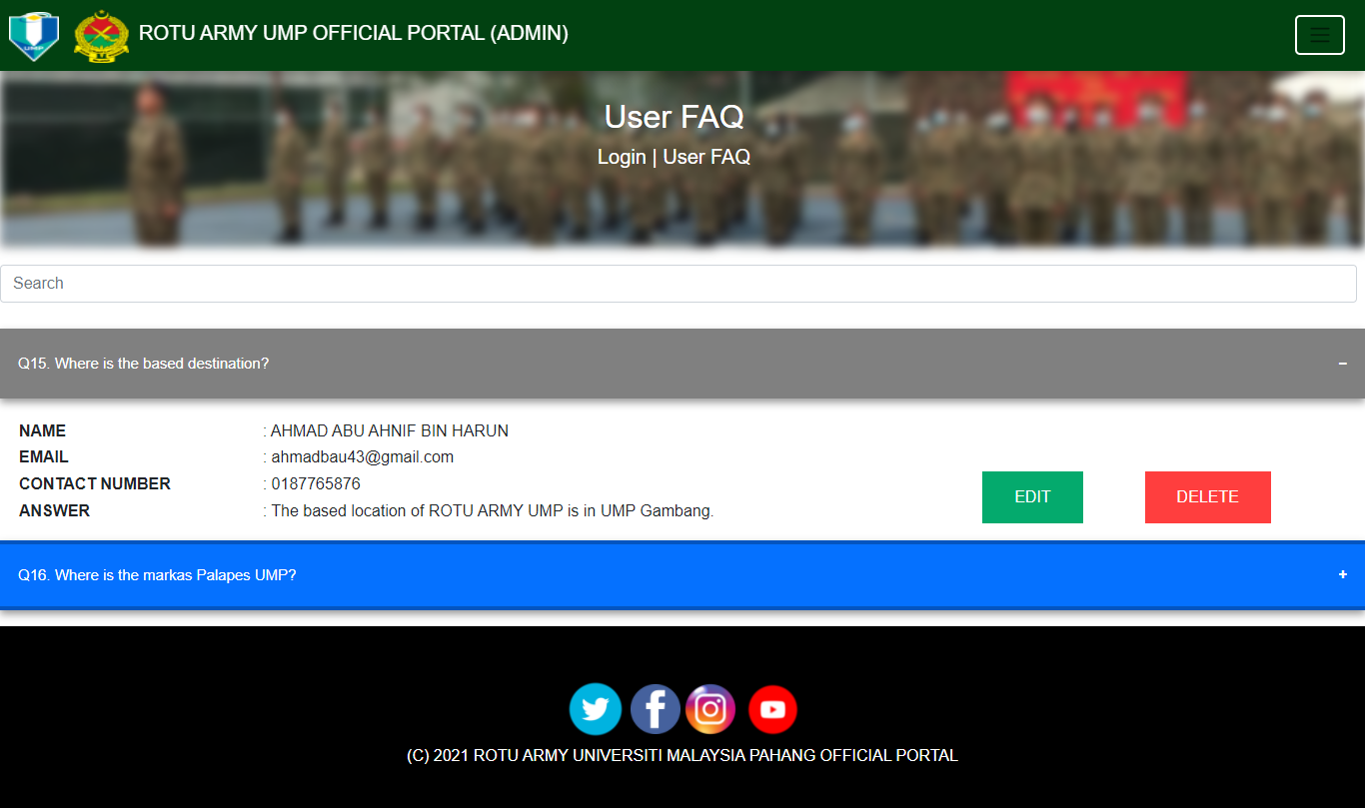

Figure 4.10 User Frequently Asked Question for Admin page

Figure 4.11 shows the Update Frequently Asked Question for Admin page. Admin can answer the user question by insert the answer in the text area.

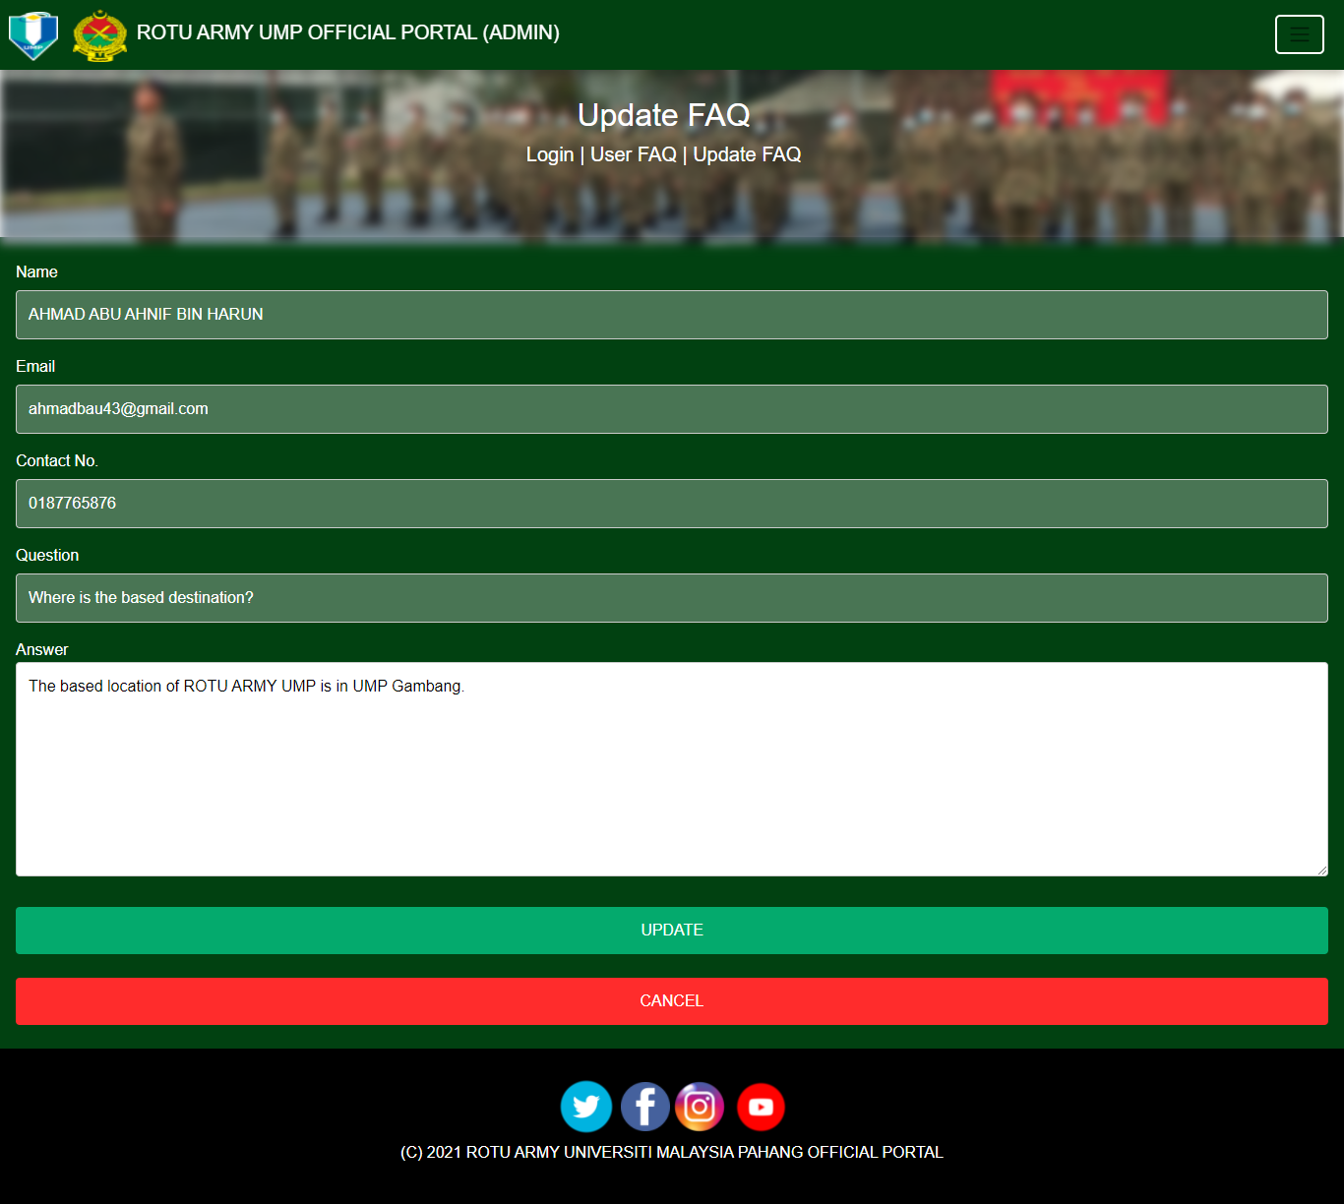

Figure 4.11 Update Frequently Asked Question for Admin page

Figure 4.12 shows the Navigation Tab for Admin page. The tabs include Frequently Asked Question and Contact Us details.

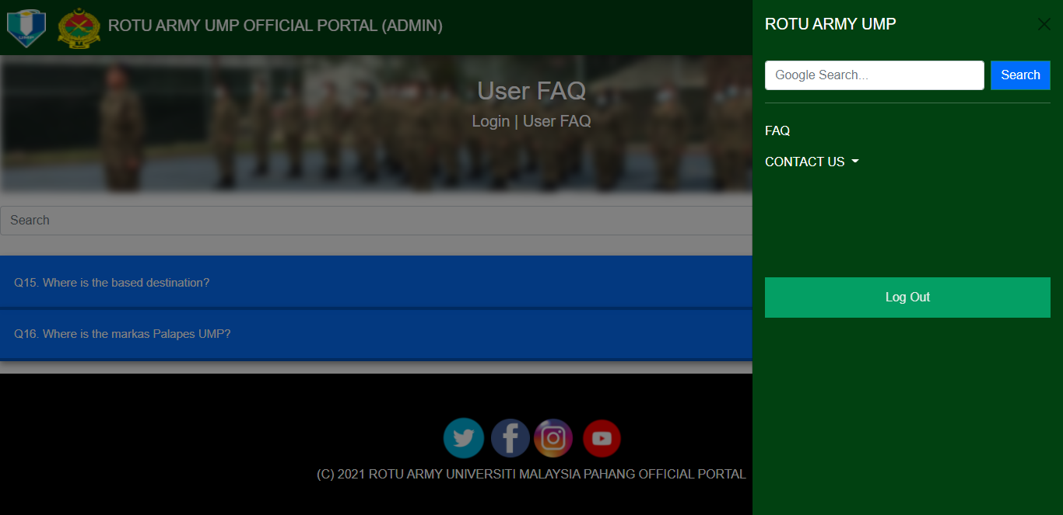

Figure 4.12 Navigation Tab for Admin page

Figure 4.13 shows the Navigation Tab for Staff page. The tab includes the New Intake Information, New Intake List, Upload Syllabus File and Contact Us details.

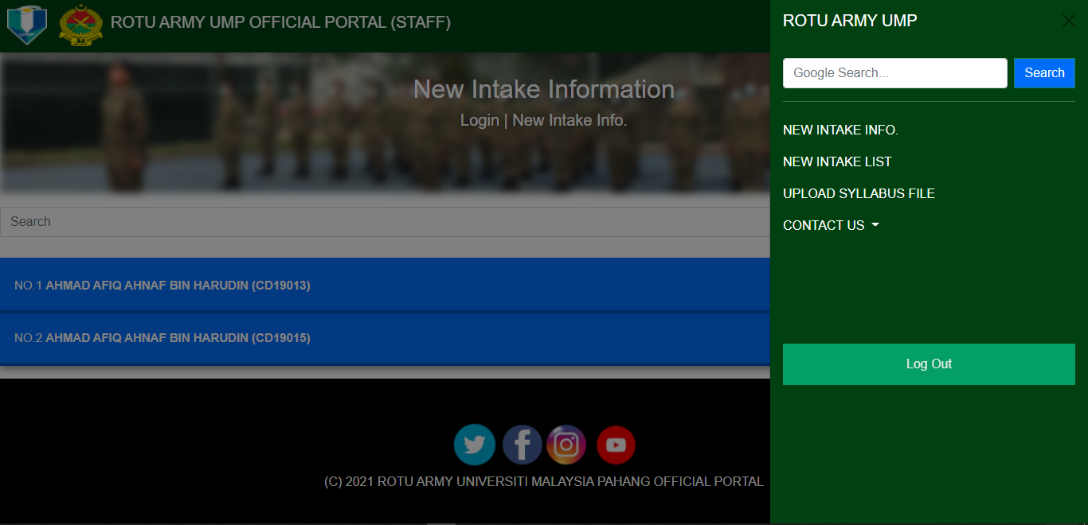

Figure 4.13 Navigation Tab for Staff page

Figure 4.14 shows the New Intake Information for Staff page. The staff can view all the new intake details and edit it by clicking the edit button. Also, the staff can print the information and delete it as well. Using search box, the staff can find any keyword related to the information.

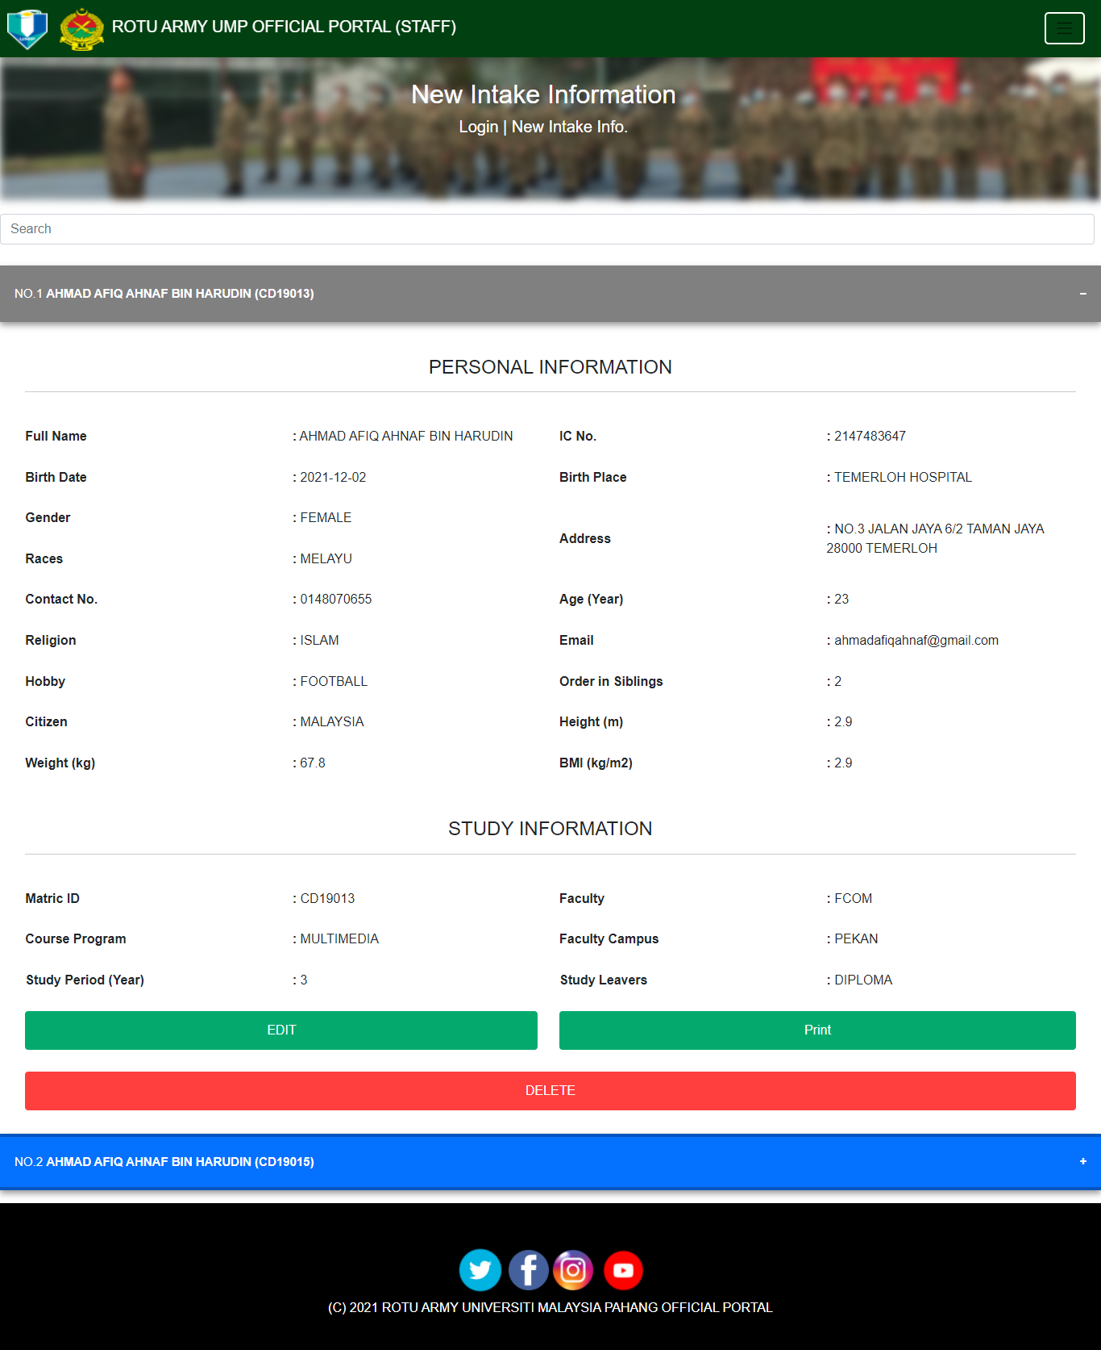

Figure 4.14 New Intake Information for Staff page

Figure 4.15 shows the Update New Intake Information for Staff page. The staff can update all the new intake information by key in the required information. By clicking the Update button, the information will be saved or cancel it by clicking the Cancel button.

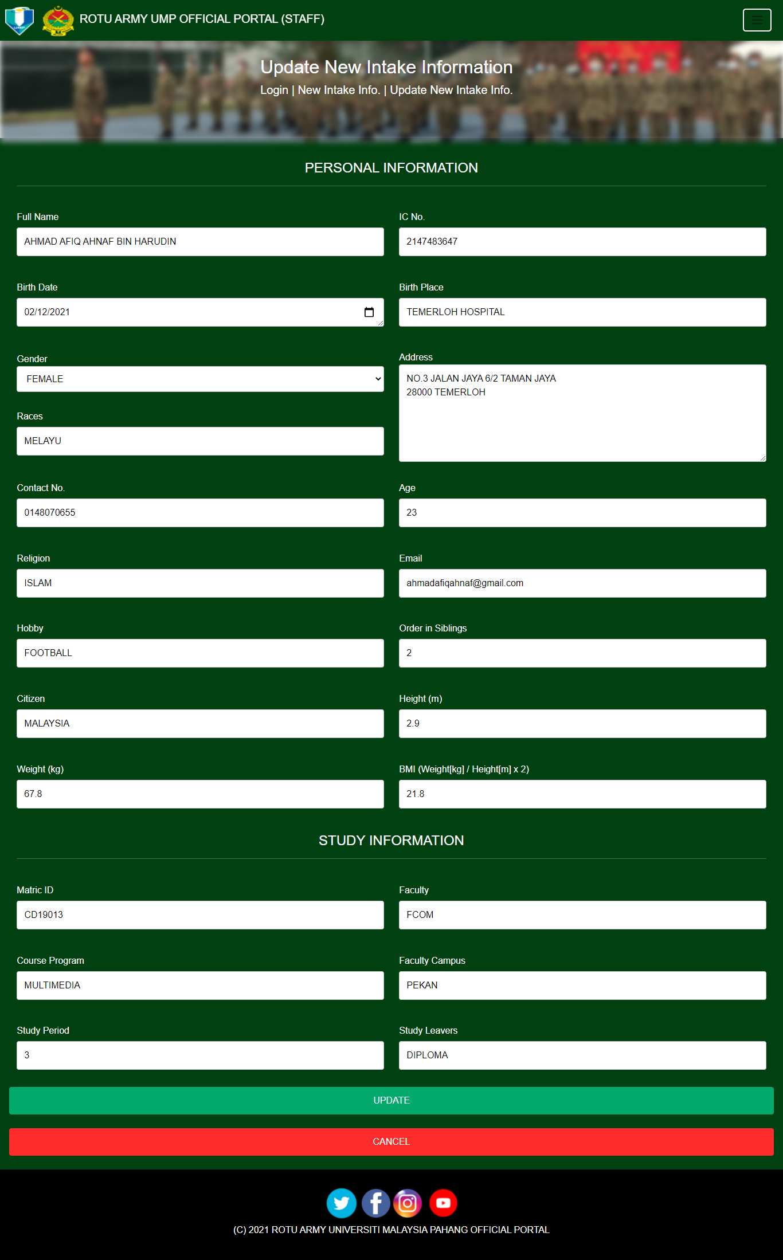

Figure 4.15 Update New Intake Information for Staff page

Figure 4.16 shows the New Intake List for Staff page. The staff can view all the new intake information in a table for more clearly. Also, the staff can print the table by clicking the Print button.

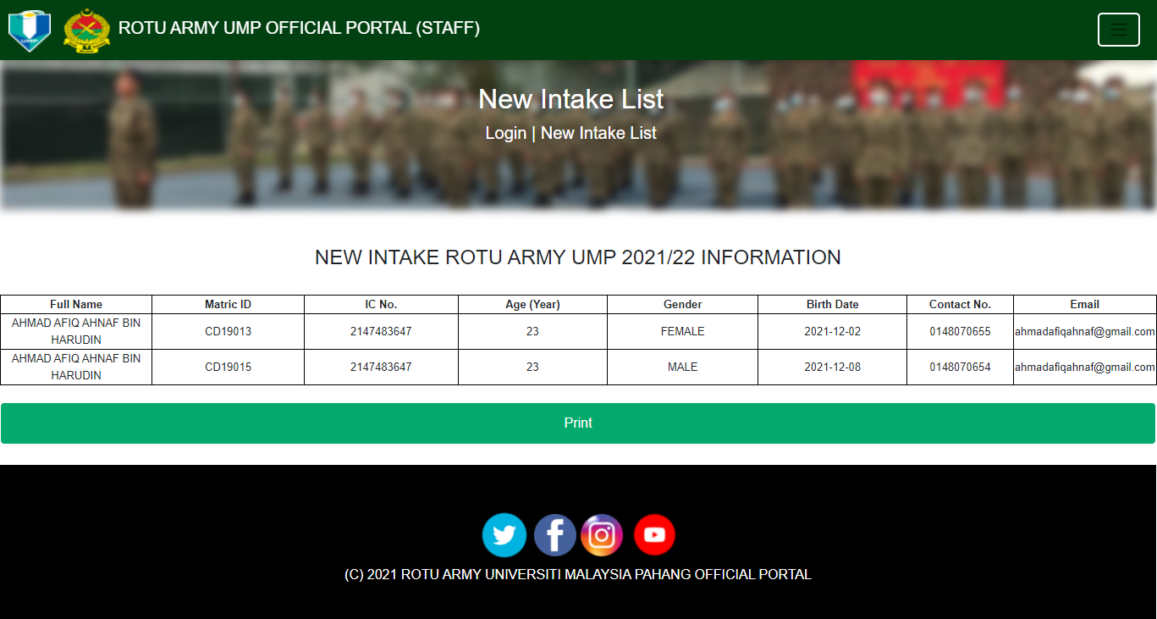

Figure 4.16 New Intake List for Staff page

Figure 4.17 shows the Upload Syllabus File for Staff page. The staff can upload any files for the current intake learning or module. By clicking the Choose File button to upload the files and then submit the files by clicking the Submit button. Also, the staff can view all the uploaded files below.

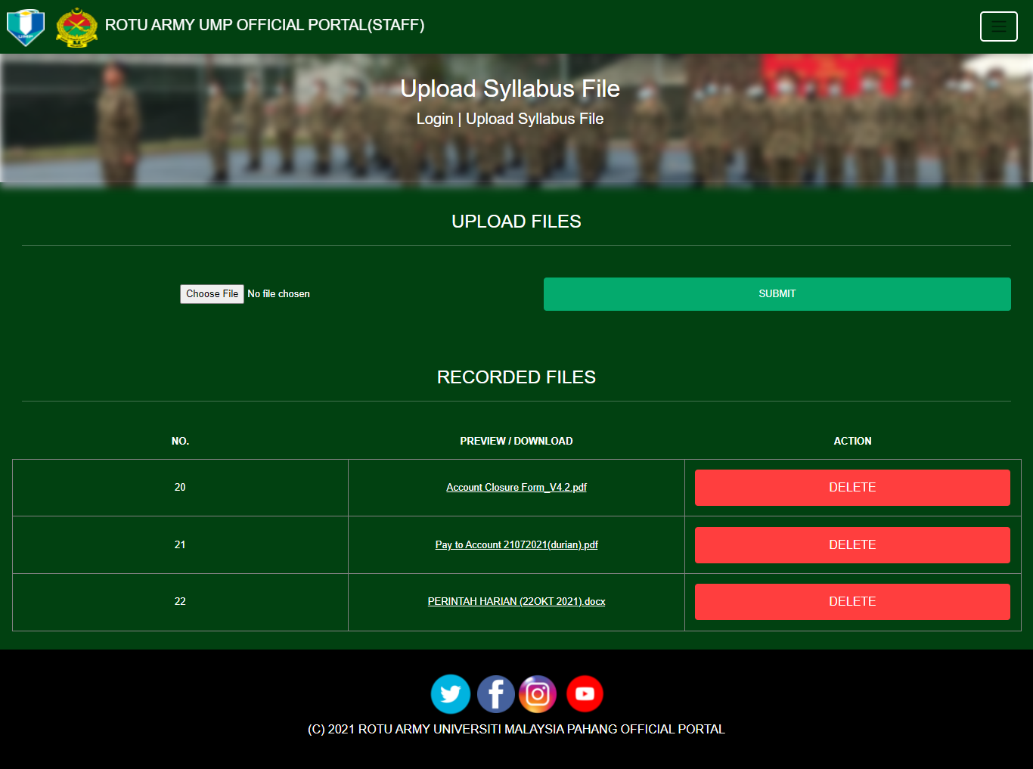

Figure 4.17 Upload Syllabus File for Staff page

Figure 4.18 shows the Syllabus Download List for Current Intake page. The current intake can view and download the files by clicking the hyperlink attached each file.

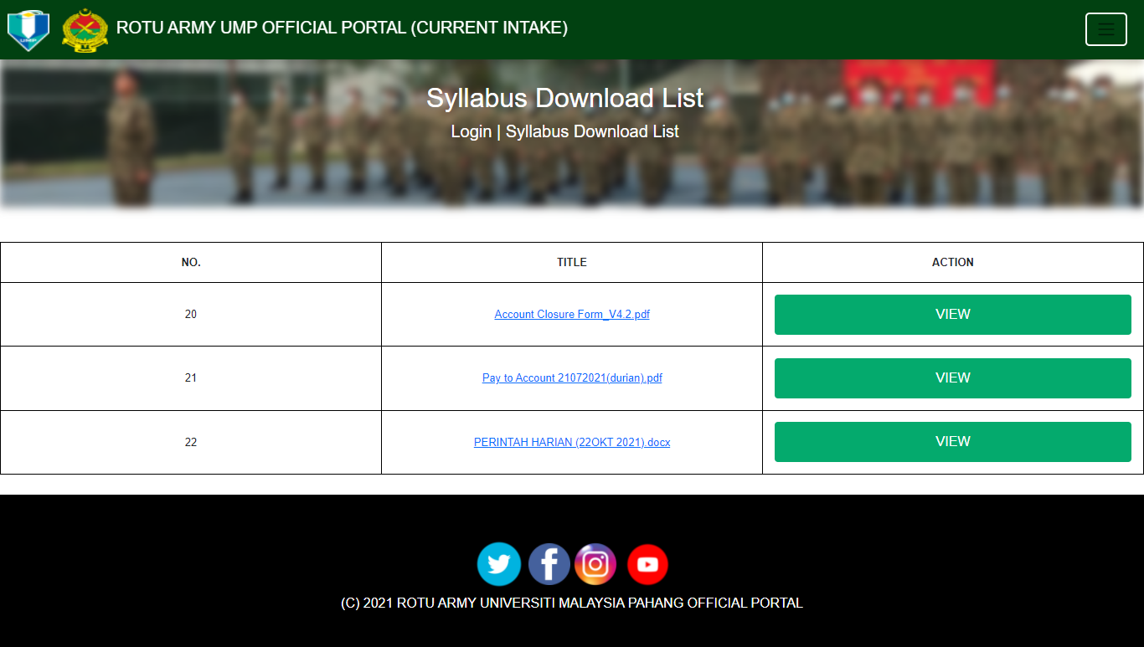

Figure 4.18 Syllabus Download List for Current Intake page

Figure 4.19 shows the Navigation Tab for the Current Intake page. The tabs include Syllabus Download List and Contact Us details.

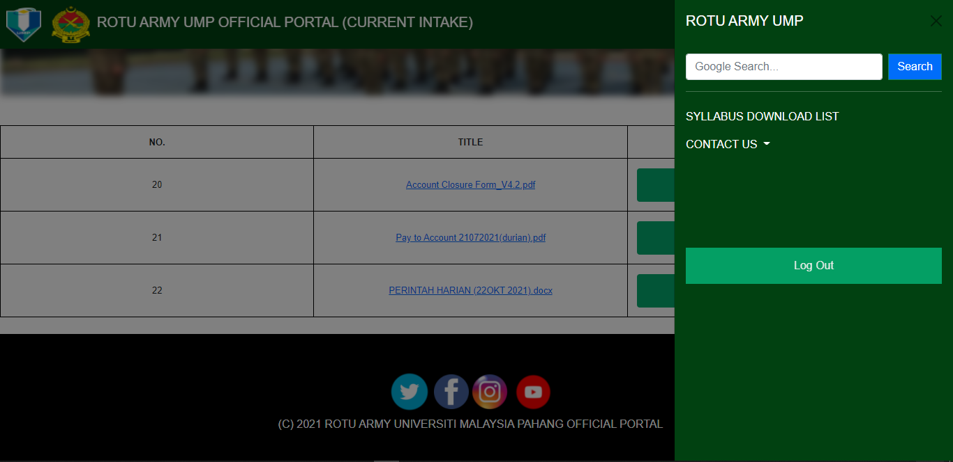

Figure 4.19 Navigation Tab for Current Intake page

## Discussion

For this phase, user and admin need to test the portal for the user acceptance evaluation. The result shows any problem occur in the portal that need to be fix and improved. The public user, admin, staff, current intake, and new intake also need to fill user acceptance test form and comment to evaluate the portal. The user acceptance test form for user will divide by five type which are new intakes, current intakes, admin, public user, and staffs. Based on the user acceptance test result, all the testers are familiar and understandable in using this portal. Majority of the user take short time to understand the functional requirement of the portal. The test results can refer at Appendix E.

This test conducted to find the requirement that can be improve and add to the future improvise system. The use of the Malay language in this evaluation form is to ease the student and staff to understand properly the information given.

Table 4.1 User Acceptance Test Form for Public User

|  |  |  |  |  |  |  |
| --- | --- | --- | --- | --- | --- | --- |
| Name | |  | | | | |
| User Categories | | Public User | | | | |
| Age | |  | | | | |
| Date | |  | | | | |
| No. | Acceptance Requirement | Critical | | Test Result | | Comment |
| Yes | No | Accept | Reject |
| 1 | Are you interested in this system? |  |  |  |  |  |
| 2 | Do you understand all the information contained in this portal? |  |  |  |  |  |
| 3 | Do you have any difficulty using this portal? |  |  |  |  |  |
| 4 | Is the information provided in this portal not too concise? |  |  |  |  |  |
| 5 | Can this portal help you in finding all the information related to ROTU ARMY UMP? |  |  |  |  |  |
| 6 | Do you understand how to use this portal? |  |  |  |  |  |
| 7 | Is it easy to use this portal? |  |  |  |  |  |
| 8 | Can this portal be used for the future? |  |  |  |  |  |
| 9 | Are there any improvements to this portal? |  |  |  |  |  |
| 10 | Are you satisfied with this portal? |  |  |  |  |  |

Based on Table 4.1, the expectation result that the project will satisfy the user and will ease the user to use the portal. Also, any problem that occurs and found from the test will be improvise as possible by the developer. The project can give many benefits to the public user especially in ROTU ARMY UMP to manage their organization in this portal.

Table 4.2 User Acceptance Test Form for Admin

|  |  |  |  |  |  |  |
| --- | --- | --- | --- | --- | --- | --- |
| Name | |  | | | | |
| User Categories | | Admin | | | | |
| Age | |  | | | | |
| Date | |  | | | | |
| No. | Acceptance Requirement | Critical | | Test Result | | Comment |
| Yes | No | Accept | Reject |
| 1 | Can you login to the portal? |  |  |  |  |  |
| 2 | Do you familiar with the design of the interface? |  |  |  |  |  |
| 3 | Do you understand all the information given? |  |  |  |  |  |
| 4 | Can you proceed to the edit/update page? |  |  |  |  |  |
| 5 | Can you edit the answer of the related information? |  |  |  |  |  |
| 6 | Can you submit the answer? |  |  |  |  |  |
| 7 | Can you cancel your answer and go back to previous page? |  |  |  |  |  |
| 8 | Can you delete some of the question? |  |  |  |  |  |
| 9 | Can you search any data in the page? |  |  |  |  |  |
| 10 | Can you logout from the portal? |  |  |  |  |  |

Based on Table 4.2, the expectation result that the project will satisfy the user and will ease the user to use the portal. Also, any problem that occurs and found from the test will be improvise as possible by the developer. The project can give many benefits to admin especially in ROTU ARMY UMP to manage their organization in this portal.

Table 4.3 User Acceptance Test Form for Staff

|  |  |  |  |  |  |  |
| --- | --- | --- | --- | --- | --- | --- |
| Name | |  | | | | |
| User Categories | | Staff | | | | |
| Age | |  | | | | |
| Date | |  | | | | |
| No. | Acceptance Requirement | Critical | | Test Result | | Comment |
| Yes | No | Accept | Reject |
| 1 | Can you login to the portal? |  |  |  |  |  |
| 2 | Do you understand the new intake information? |  |  |  |  |  |
| 3 | Do you clearly view all the font size and colour of the information? |  |  |  |  |  |
| 4 | Can you edit some of the information given in update new intake information page? |  |  |  |  |  |
| 5 | Can print one of the student information in new intake information page? |  |  |  |  |  |
| 6 | Can you delete one of the student information? |  |  |  |  |  |
| 7 | Can you cancel the update process? |  |  |  |  |  |
| 8 | Is it all the updated information, right? |  |  |  |  |  |
| 9 | Can you logout the page? |  |  |  |  |  |
| 10 | Can you upload any file in the upload syllabus file page? |  |  |  |  |  |

Based on Table 4.3, the expectation result that the project will satisfy the user and will ease the user to use the portal. Also, any problem that occurs and found from the test will be improvise as possible by the developer. The project can give many benefits to the staff especially in ROTU ARMY UMP to manage their organization in this portal.

Table 4.4 User Acceptance Test Form for Current Intake

|  |  |  |  |  |  |  |
| --- | --- | --- | --- | --- | --- | --- |
| Name | |  | | | | |
| User Categories | | Current Intake | | | | |
| Age | |  | | | | |
| Date | |  | | | | |
| No. | Acceptance Requirement | Critical | | Test Result | | Comment |
| Yes | No | Accept | Reject |
| 1 | Can you login to the portal? |  |  |  |  |  |
| 2 | Do you familiar with all the information given? |  |  |  |  |  |
| 3 | Can you view some of the file in the syllabus download list page? |  |  |  |  |  |
| 4 | Can you download the file? |  |  |  |  |  |
| 5 | Can you find any information by typing in the google search box in the navigation tab? |  |  |  |  |  |
| 6 | Is it the website responsive? |  |  |  |  |  |
| 7 | Is it easy to use this portal? |  |  |  |  |  |
| 8 | Can this portal be used for the future? |  |  |  |  |  |
| 9 | Are there any improvements to this portal? |  |  |  |  |  |
| 10 | Can you logout from the portal? |  |  |  |  |  |

Based on Table 4.4, the expectation result that the project will satisfy the user and will ease the user to use the portal. Also, any problem that occurs and found from the test will be improvise as possible by the developer. The project can give many benefits to current intake especially in ROTU ARMY UMP to manage their organization in this portal.

Table 4.5 User Acceptance Test Form for New Intake

|  |  |  |  |  |  |  |
| --- | --- | --- | --- | --- | --- | --- |
| Name | |  | | | | |
| User Categories | | New Intake | | | | |
| Age | |  | | | | |
| Date | |  | | | | |
| No. | Acceptance Requirement | Critical | | Test Result | | Comment |
| Yes | No | Accept | Reject |
| 1 | Can you find the new intake registry button? |  |  |  |  |  |
| 2 | Do you understand all the information contained in this portal? |  |  |  |  |  |
| 3 | Do you have any difficulty using this portal? |  |  |  |  |  |
| 4 | Can you fill all the information required? |  |  |  |  |  |
| 5 | Can this portal help you in finding all the information related to ROTU ARMY UMP? |  |  |  |  |  |
| 6 | Do you understand how to use this portal? |  |  |  |  |  |
| 7 | Can you submit the information? |  |  |  |  |  |
| 8 | Can you cancel the application form and go to home page? |  |  |  |  |  |
| 9 | Is it have pop up message which state that you have succeed submit the application? |  |  |  |  |  |
| 10 | Are you satisfied with this portal? |  |  |  |  |  |

Based on Table 4.5, the expectation result that the project will satisfy the user and will ease the user to use the portal. Also, any problem that occurs and found from the test will be improvise as possible by the developer. The project can give many benefits to the new intake especially in ROTU ARMY UMP to manage their organization in this portal.

## Chapter Summary

For this section, the testing will be conducted to find the requirement from the user. The User Acceptance Test will be record as the user fill the feedback that will give to the student and the staff of the University Malaysia Pahang. Also, the feedback will be given to the public people. For the next chapter which is Chapter 5 will discuss about the conclusion of the thesis and the portal.

# CONCLUSION

## Objective Revisited

During the implementation of the ROTU ARMY UMP Portal, there are four objective that being focused. The first objective is to design a ROTU ARMY UMP Portal system. The second objective is to develop a portal that display and explaining the information and news about the ROTU ARMY UMP for the UMP students. The third objective is to develop a portal that ease the student and staff to manage the ROTU ARMY UMP organization. The last objective is to verify bugs of the ROTU ARMY UMP Portal.

In the first objective which is to design a ROTU ARMY UMP Portal system, The objective successfully implemented. The portal consists of several pages such as the Home, Login, New Intake Registry, Frequently Asked Question, About Us, Organization Chart, Contact Us and News Pages for public user. For the admin, the page related such as User Frequently Asked Question which they can answer the user question. Then, for the staff, page relate such as New Intake Information, New Intake List and Upload Syllabus File. Also, for the current intake, the page relates include the Syllabus Download List. With this project development, the efficiency in delivering the information will increase rapidly to the students especially.

For the second objective, to develop a portal that display and explaining the information and news about the ROTU ARMY UMP for the UMP students. This objective has achieved by developing the information about the organization such as the history, commandant foreword and Ikrar Kesatria. Also, there are some news related to the organization and newest and previous activities that has been done.

Other than that, the third objective which is to develop a portal that ease the student and staff to manage the ROTU ARMY UMP organization. The new intake can fill the registration form for new intake of the organization. Also, the staff can manage all the new intake information and can upload any file related with the syllabus of the organization. The current intake can view and download all the uploaded files and the admin can response the public user question in the portal.

Finally, the last objective, to verify bugs of the ROTU ARMY UMP Portal. We have implemented the testing phase. There are five user type such as admin, staff, public user, current intake, and new intake. They need to fill all the question which can verify any bugs or errors of the portal. Then, the developer can trace the errors and make solution related to the errors. This will improve and enhance the portal to be use without or less error.

## Limitation

Due to the limitation of programming skill, knowledge and the time taken to complete the portal development, there have several limitations which are:

The use of responsive interface will give more time to be implemented. This happen because the devices screen resolution is varying, so we need to implement more media screen styling in CSS page.

The knowledge that needed to develop the portal also need to be open which need to research and learn at the open-source website or article to gain more knowledge about the existing portal. Also, the knowledge about the related existing portal is limited because they are not active in making website.

The programming skills that have learned especially in login process need to be improvise. If the user enters wrong username, password or user type, the portal does no mention any alert message to the user. They need to go back to the previous page manually which is home page.

## Future Work

The ROTU ARMY UMP Portal has advance potential and can give benefit to the user in the future. There are some improvements that can be done to the portal. The first improvement is to fix the login process. The user can identify whether they unsuccessfully login to the internal portal. By implement the alert message, this will give aware for the user where they are fill the wrong username, password, or user type.

Moreover, the use of responsive layout needs to be improvised. This can be done when we need to implement the responsive element to every container or division that we have made. This solution can give more effective and systematic arrangement of the portal.

Lastly, the security of the personal information. In the portal, we can see the login id of the user which this can be harmed for the user. Any stranger can know the login id if they try to attack the portal. Also, the php language or text can be see in the inspect tools in the google site. We need to hide the php text from expose to the public by implement external file for php text only.

**REFERENCES**

Ahmad, A. (2021). Home. ROTU.unimas.my. Retrieved 8 June 2021, from http://www.ROTU.unimas.my/.

Contributors, W. (2021). Reserve Officer Training Unit - Wikipedia. En.wikipedia.org. Retrieved 8 June 2021, from https://en.wikipedia.org/wiki/Reserve_Officer_Training_Unit.

Muhammad, F. (2018). HOME | RESERVE OFFICER TRAINING UNIT (ROTU). ROTU.upm.edu.my. Retrieved 8 June 2021, from https://ROTU.upm.edu.my/.

Najmuddin, M. (2021). Rotu ARMY UMP. Rotu ARMY UMP. Retrieved 8 June 2021, from https://rotuARMYumpmy.blogspot.com/.

ROTU, U. (2021). Pusat Kokurikulum, Universiti Utara Malaysia - ROTU. Kokuum.uum.edu.my. Retrieved 8 June 2021, from [http://kokuum.uum.edu.my/unit/ROTU](http://kokuum.uum.edu.my/unit/palapes).

Rahimah, S. (2021). KOMPLEKS ROTU UNIVERSITI MALAYA. ROTU.um.edu.my. Retrieved 8 June 2021, from https://ROTU.um.edu.my/index.

**APPENDICES**

APPENDIX A – Flowchart of ROTU ARMY UMP Portal

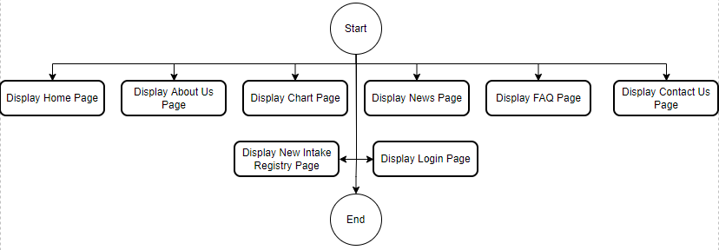

Figure 7.1 – Flowchart of the whole ROTU ARMY UMP Portal

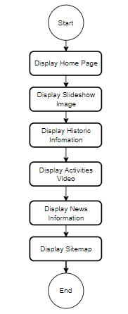

Figure 7.2 – Flowchart of the Home Page

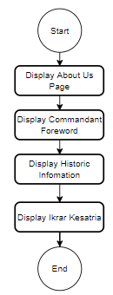

Figure 7.3 – Flowchart of the About Us Page

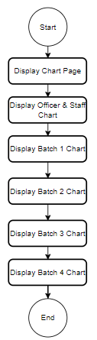

Figure 7.4 – Flowchart of the Chart Page

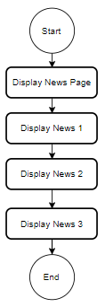

Figure 7.5 – Flowchart of the News Page

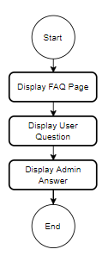

Figure 7.6 – Flowchart of the FAQ Page

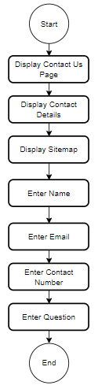

Figure 7.7 – Flowchart of the Contact Us Page

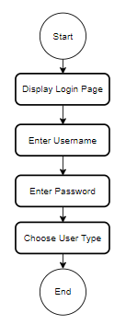

Figure 7.8 – Flowchart of the Login Page

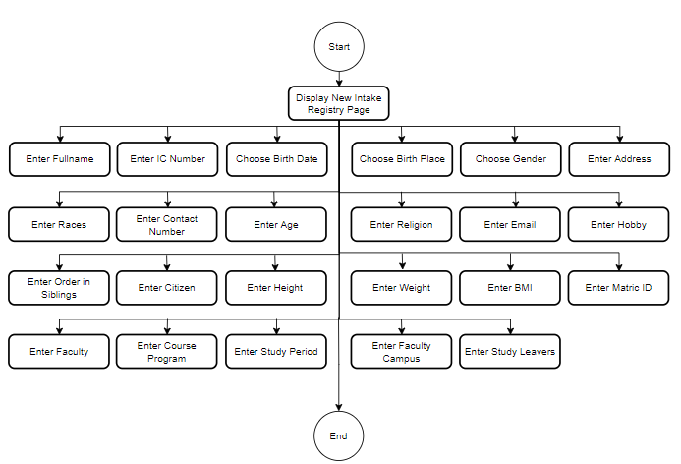

Figure 7.9 – Flowchart of the New Intake Registry Page

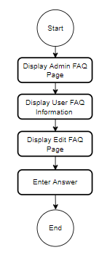

Figure 7.10 – Flowchart of the Admin FAQ Page

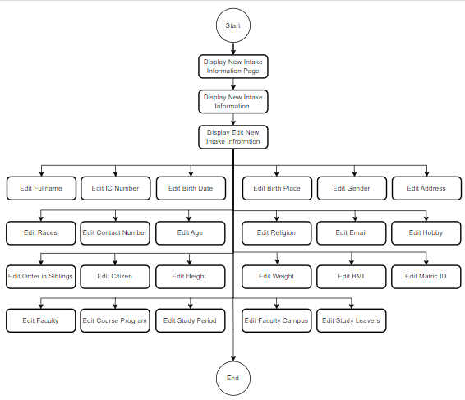

Figure 7.11 – Flowchart of the New Intake Information Page

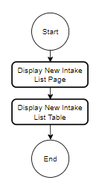

Figure 7.12 – Flowchart of the New Intake List Page

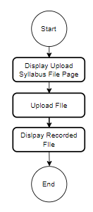

Figure 7.13 – Flowchart of the Upload Syllabus File Page

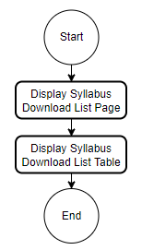

Figure 7.14 – Flowchart of the Syllabus Download List Page

APPENDIX B – Context Diagram of ROTU ARMY UMP Portal

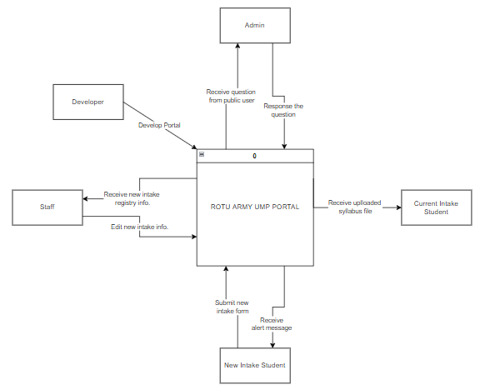

Figure 7.11 – Context Diagram of ROTU ARMY UMP Portal

APPENDIX C – Use Case Diagram of ROTU ARMY UMP Portal

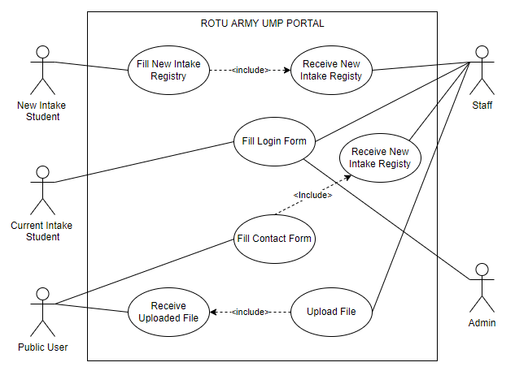

Figure 7.12 – Use Case Diagram of ROTU ARMY UMP Portal

APPENDIX D – Storyboard of ROTU ARMY UMP Portal

Table 7.1 Home Page of ROTU ARMY UMP Portal

|  |  |
| --- | --- |
| Screen Title | Home Page |
| Layout | 01 |
| Screen Layout |  |
| Description | In this page, there is slideshow images which related to the organization activities. Also, the historic information and the video about the previous annual camping. Then, the news about the activities happens during the semester. The display of sitemap of the main location of the organization. |

Table 7.2 Login Page of ROTU ARMY UMP Portal

|  |  |
| --- | --- |
| Screen Title | Login Page |
| Layout | 02 |
| Screen Layout |  |
| Description | In this page, the user can login the internal page by clicking the left side login button. Login page will pop up and the user can fill all the information required. The information includes the army number, user type and the password. The user type consists with new intake, staff, and admin. The data will retrieve from the database. |

Table 7.3 Frequently Asked Question Page of ROTU ARMY UMP Portal

|  |  |
| --- | --- |
| Screen Title | Frequently Asked Question Page |
| Layout | 03 |
| Screen Layout |  |
| Description | In the FAQ page, the user can view the question and the answer related with the organization. The question may vary which has been ask from citizen. The personal information of the user does not show as to protect the privacy of the user. The admin of the portal will answer the question as soon as possible. |

Table 7.4 New Intake Registry Page of ROTU ARMY UMP Portal

|  |  |
| --- | --- |
| Screen Title | New Intake Registry Page |
| Layout | 04 |
| Screen Layout |  |
| Description | The new intake student needs to fill all require information. All the data will send to the in-charge staff that will process the application. By clicking the submit button, the data will be insert to the database. By clicking the cancel button, the page will go back to the Home page. |

Table 7.5 About Us Page of ROTU ARMY UMP Portal

|  |  |
| --- | --- |
| Screen Title | About Us Page |
| Layout | 05 |
| Screen Layout |  |
| Description | In this page, the user can view and read the information that related to this organization. The information includes the History ROTU ARMY UMP, Ikrar Kesatria, and Commandant Foreword. Also, there have the image that role as the attractiveness for the page. |

Table 7.6 Organization Chart Page of ROTU ARMY UMP Portal

|  |  |
| --- | --- |
| Screen Title | Organization Chart Page |
| Layout | 06 |
| Screen Layout |  |
| Description | In this page, the user can view the information of the ROTU ARMY UMP organization chart. There are five organization charts in this page. The organization charts include all ROTU ARMY UMP Officer & Staff Chart, First Intake Batch Chart, Second Intake Batch Chart, Third Intake Batch Chart, and Forth Intake Batch Chart. |

Table 7.7 Contact Us Page of ROTU ARMY UMP Portal

|  |  |
| --- | --- |
| Screen Title | Contact Us Page |
| Layout | 07 |
| Screen Layout |  |
| Description | In this page, the user can view the contact detail of the organization. The details include the address, contact number, email, and fax number. The user also can fill the contact form if have any question relate the organization. The information consists with the name, email contact number, and question. Then, the user needs to click the submit button to send the contact form to the admin. Also, the user can view the sitemap of the office location of the organization. |

Table 7.8 Admin FAQ Page of ROTU ARMY UMP Portal

|  |  |
| --- | --- |
| Screen Title | Admin FAQ Page |
| Layout | 08 |
| Screen Layout |  |
| Description | In this page, only admin can enter this page. The admin can view the feedback from the user in the list table above. The admin also can search any data information by clicking and enter the keyword in the searching box. The feedback information includes the username, email, contact number, and the comment of the feedback. The admin can reply to the response by enter the content at the response box. Then, by clicking the submit button, the response will proceed and display in the FAQ page for public user viewing. |

Table 7.9 News Page of ROTU ARMY UMP Portal

|  |  |
| --- | --- |
| Screen Title | News Page |
| Layout | 09 |
| Screen Layout |  |
| Description | In this page, the user can view news of the ROTU ARMY UMP. The user can read the previous and latest news that have been or will be conduct by the organization. |

Table 7.10 New Intake List Page of ROTU ARMY UMP Portal

|  |  |
| --- | --- |
| Screen Title | New Intake List Page |
| Layout | 10 |
| Screen Layout |  |
| Description | In this page, the staff can view all the details about the new intake. Also, they can print and download the table above by clicking the print button. |

Table 7.11 New Intake Information Page of ROTU ARMY UMP Portal

|  |  |
| --- | --- |
| Screen Title | New Intake Information Page |
| Layout | 11 |
| Screen Layout |  |
| Description | In this page, the staff can view all the new intake information by each person. They also can edit the student data by clicking the edit button. Also, they can print each student information by clicking the print button. By clicking the delete button, they can delete each student data. |

Table 7.12 Upload Syllabus File Page of ROTU ARMY UMP Portal

|  |  |
| --- | --- |
| Screen Title | Upload Syllabus File Page |
| Layout | 12 |
| Screen Layout |  |
| Description | In this page, the staff can upload any file related with the syllabus of the organization. By clicking the choose file button, the staff can upload the file and by clicking the submit button, the file will submit to the database. It will be stored to the database and will display in the recorded file table and at the current intake page. |

Table 7.13 Syllabus Download List Page of ROTU ARMY UMP Portal

|  |  |
| --- | --- |
| Screen Title | Syllabus Download List Page |
| Layout | 13 |
| Screen Layout |  |
| Description | In this page, the current student can view the uploaded file from the staff. They can view the file and can download it to their personal devices. |

APPENDIX E – Test Result

User Acceptance Test for Public User

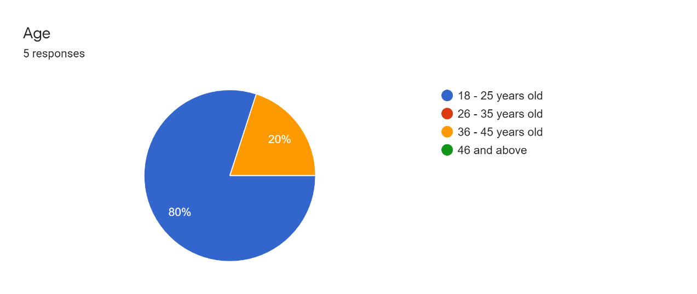

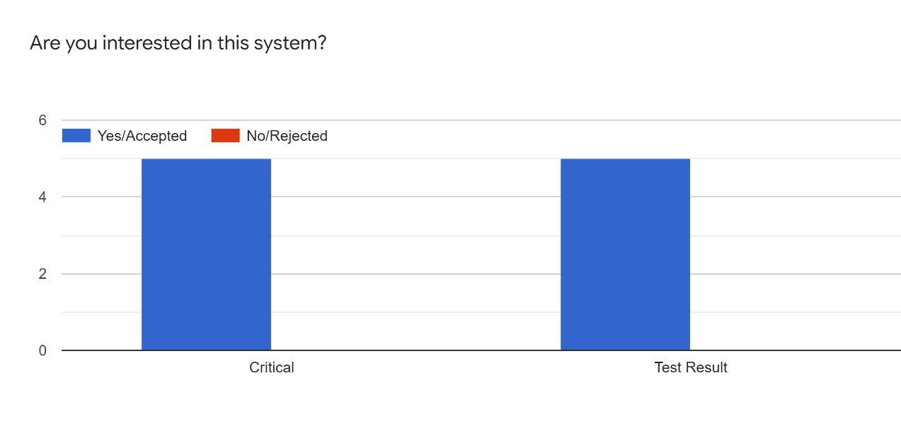

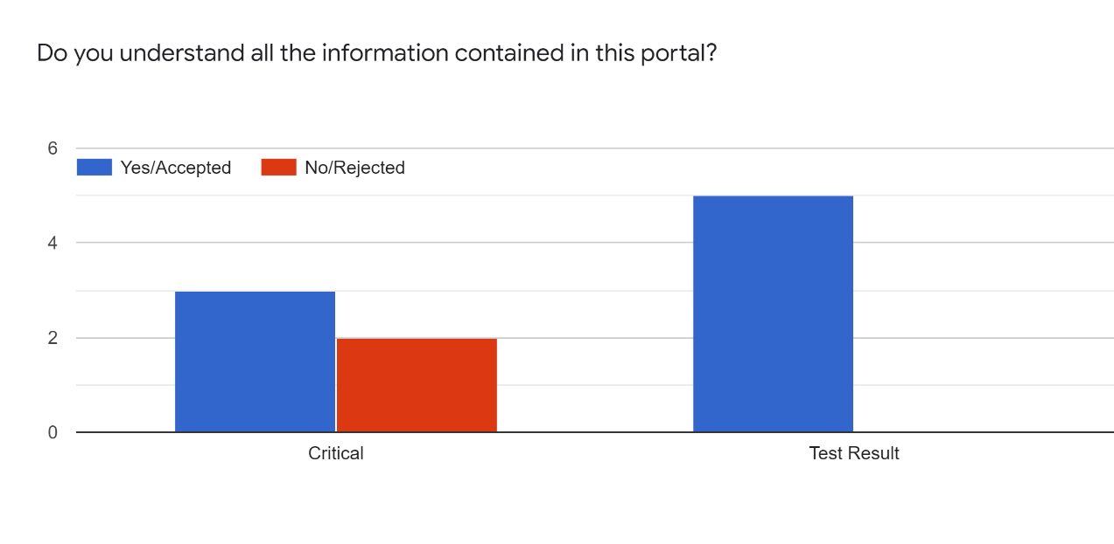

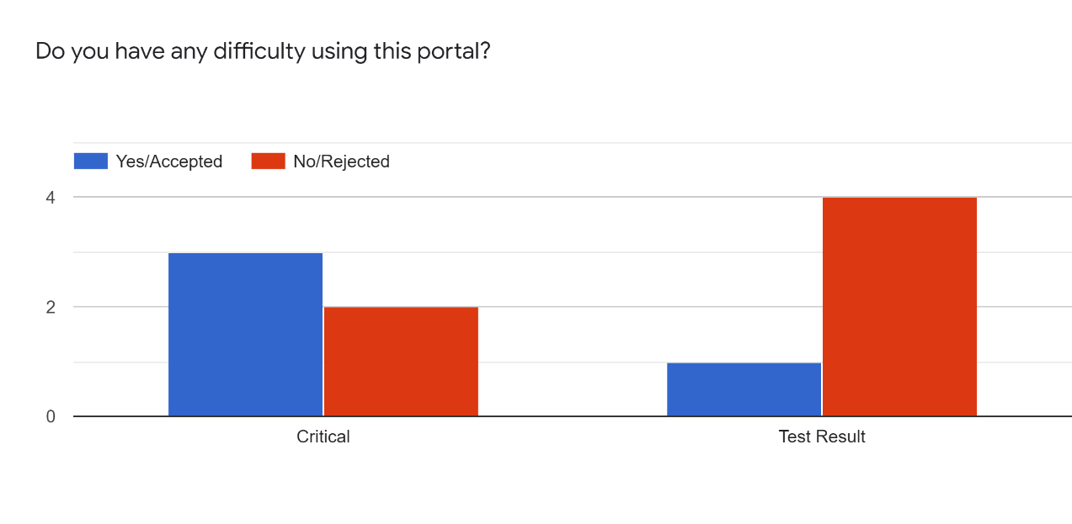

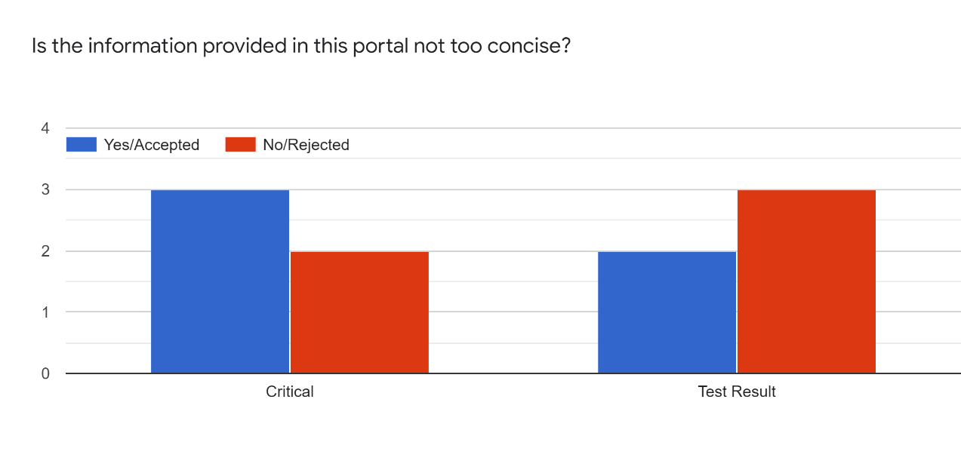

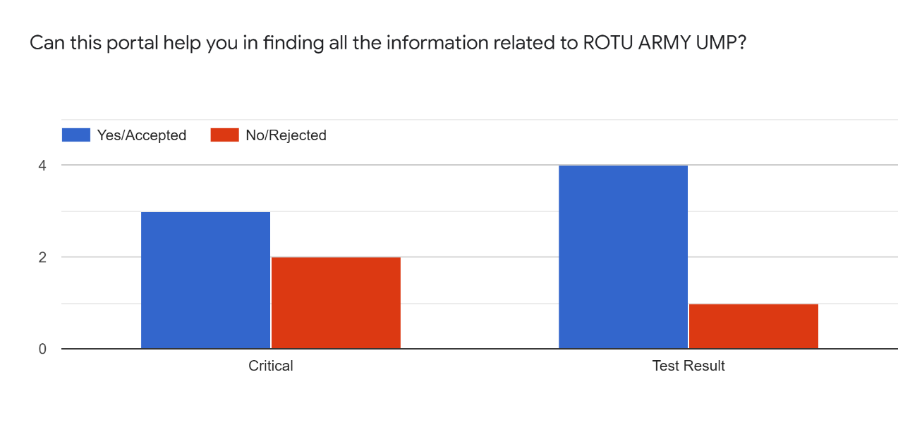

 

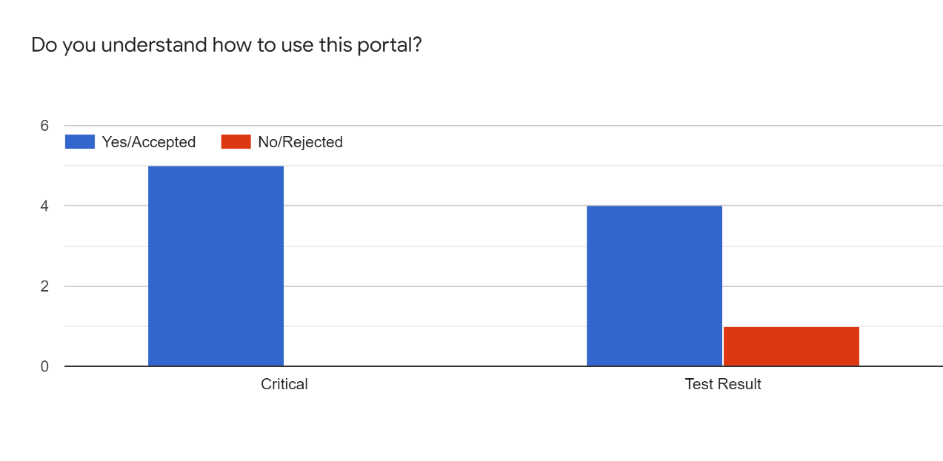

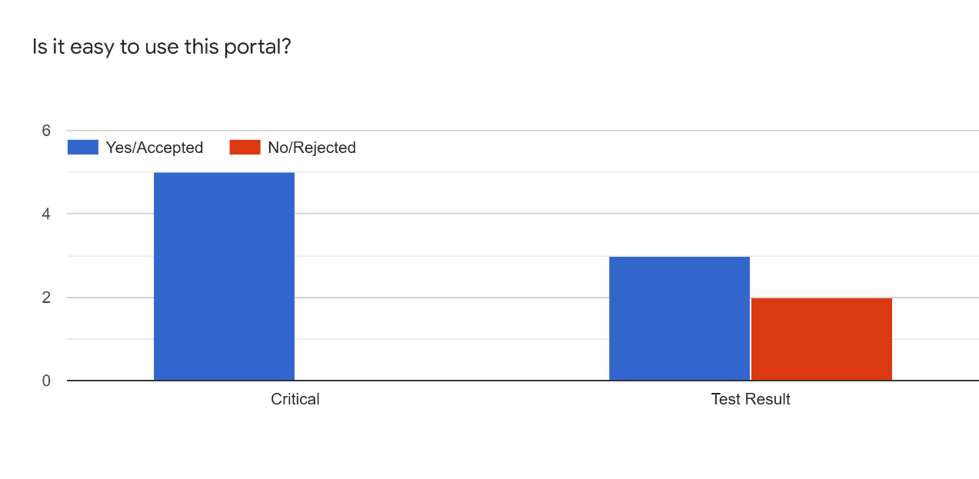

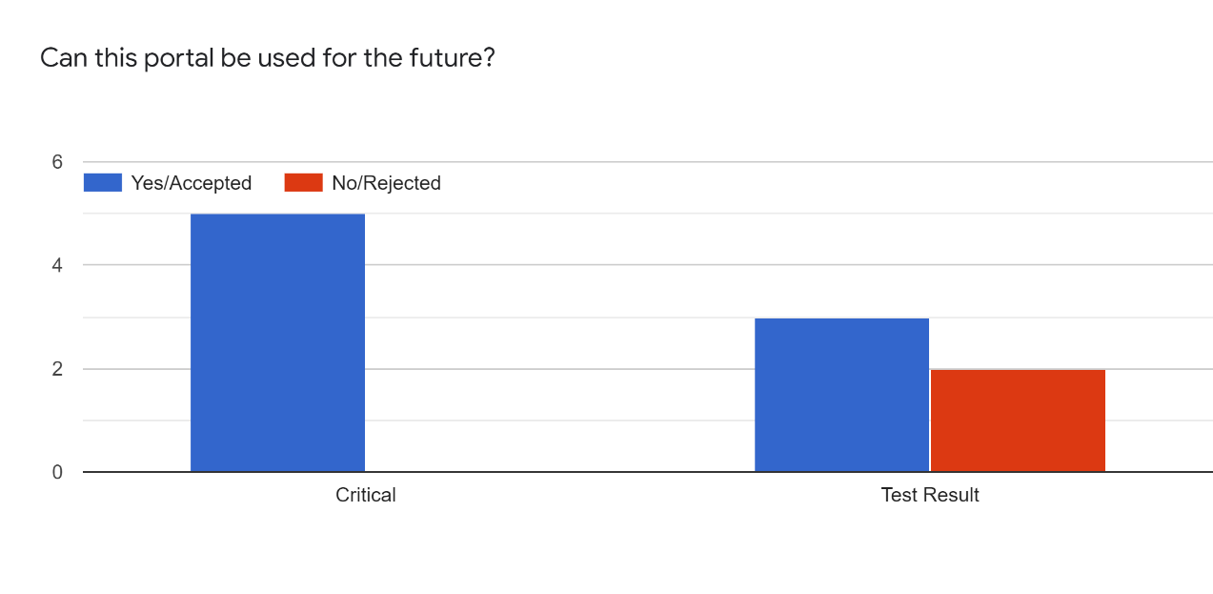

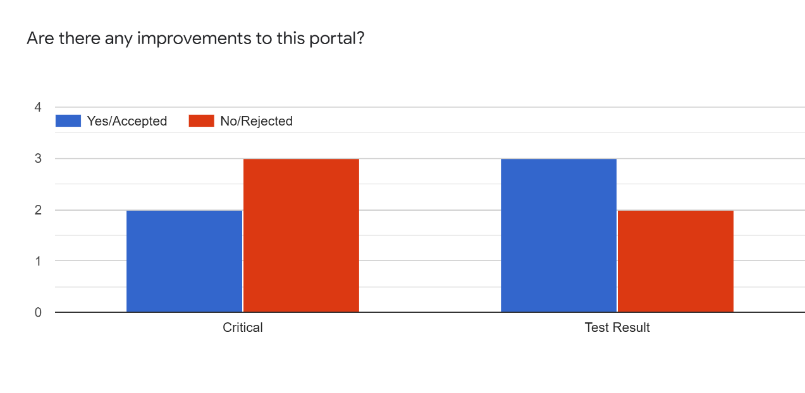

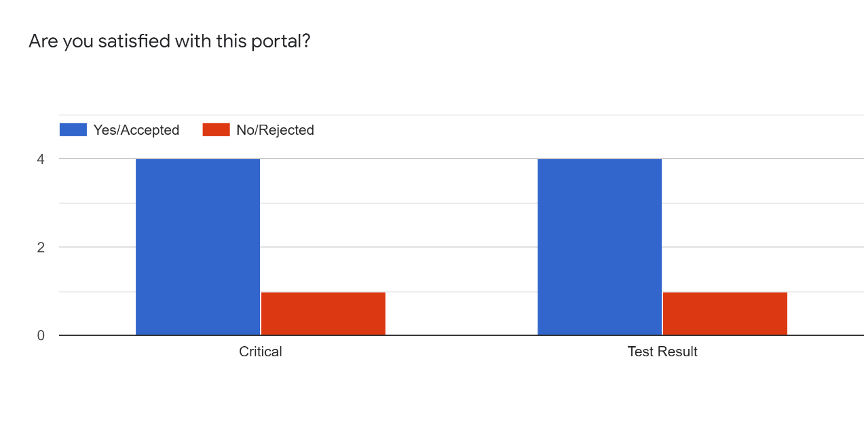

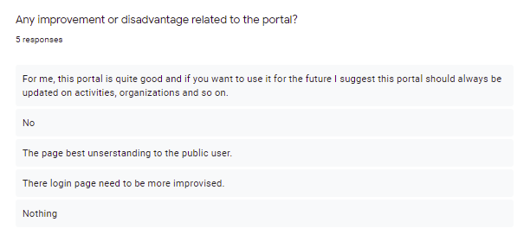

User Acceptance Test for Admin

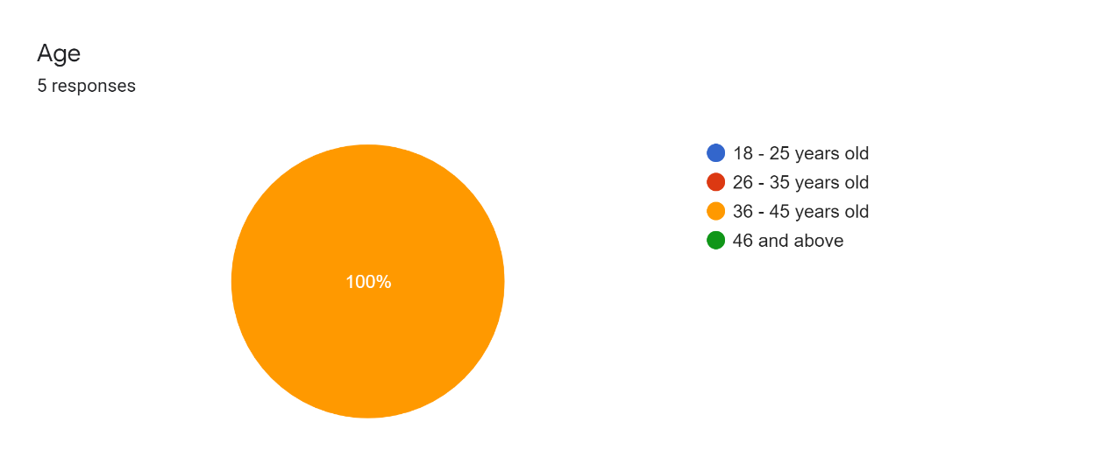

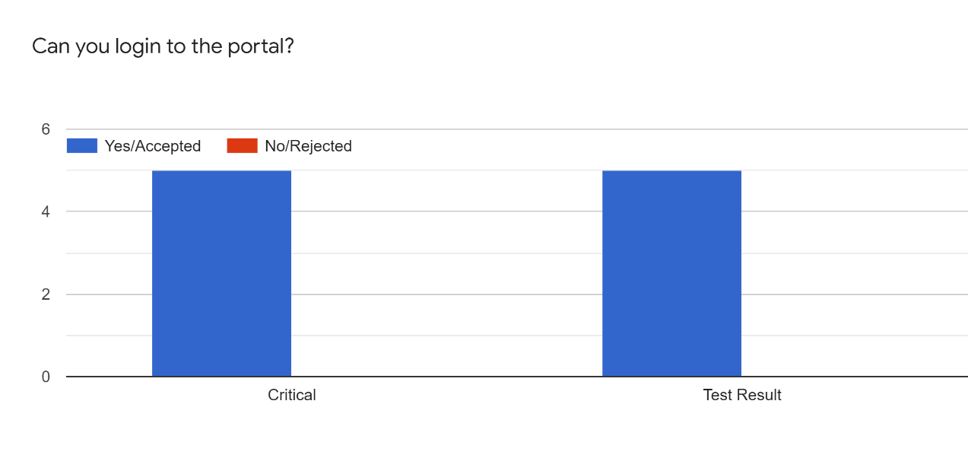

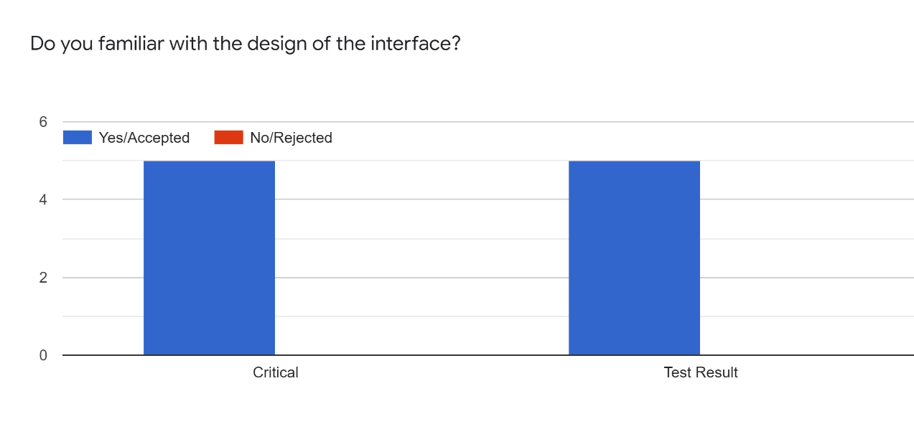

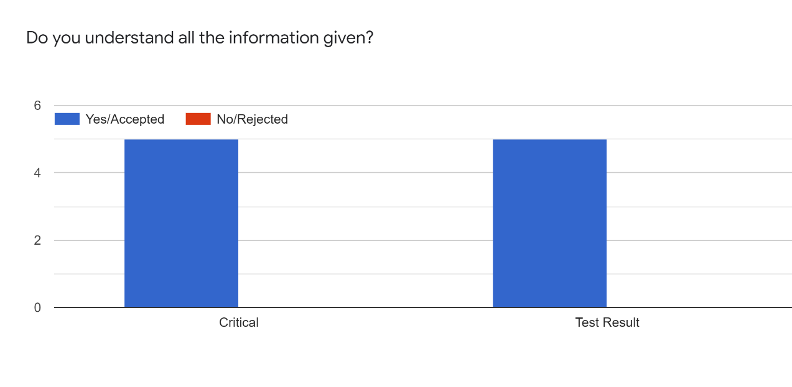

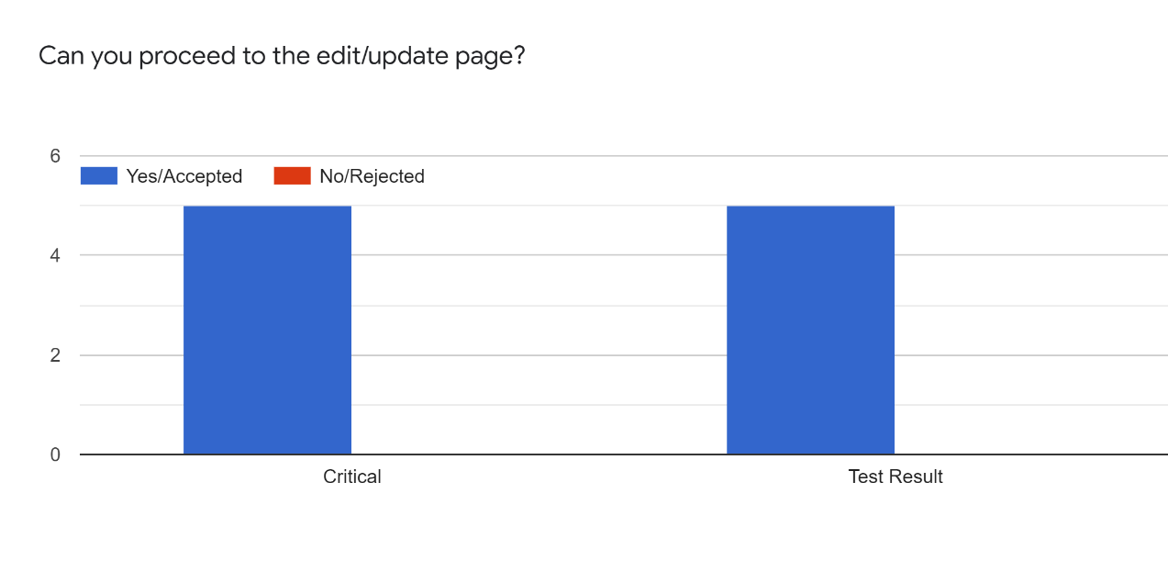

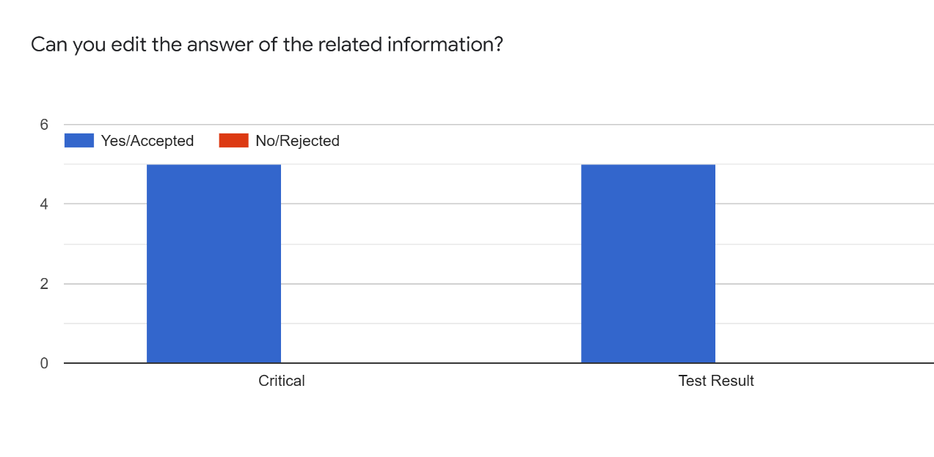

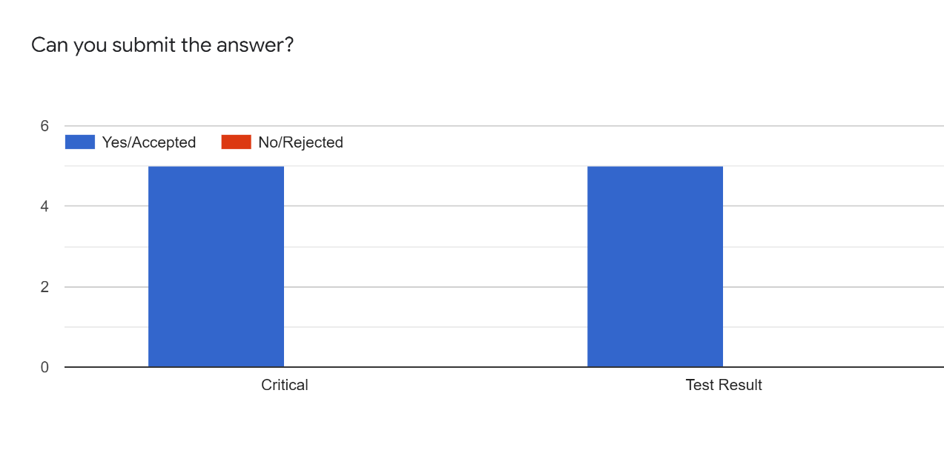

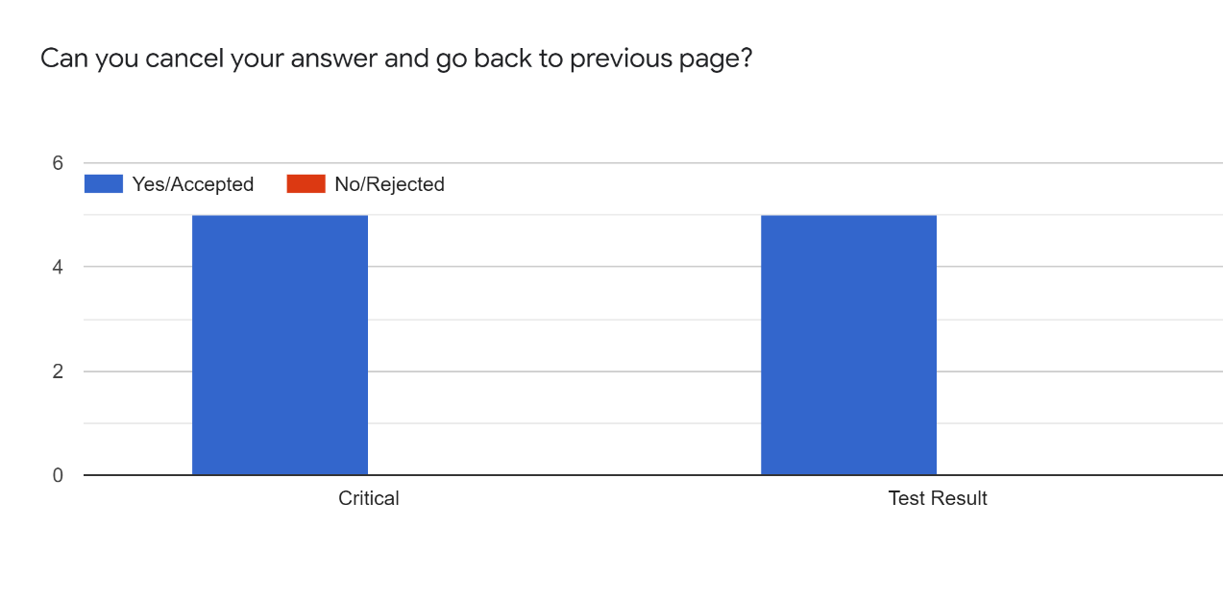

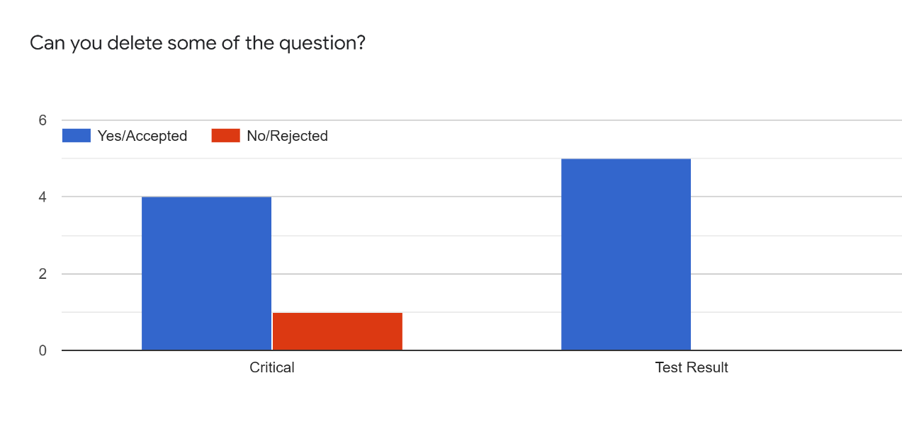

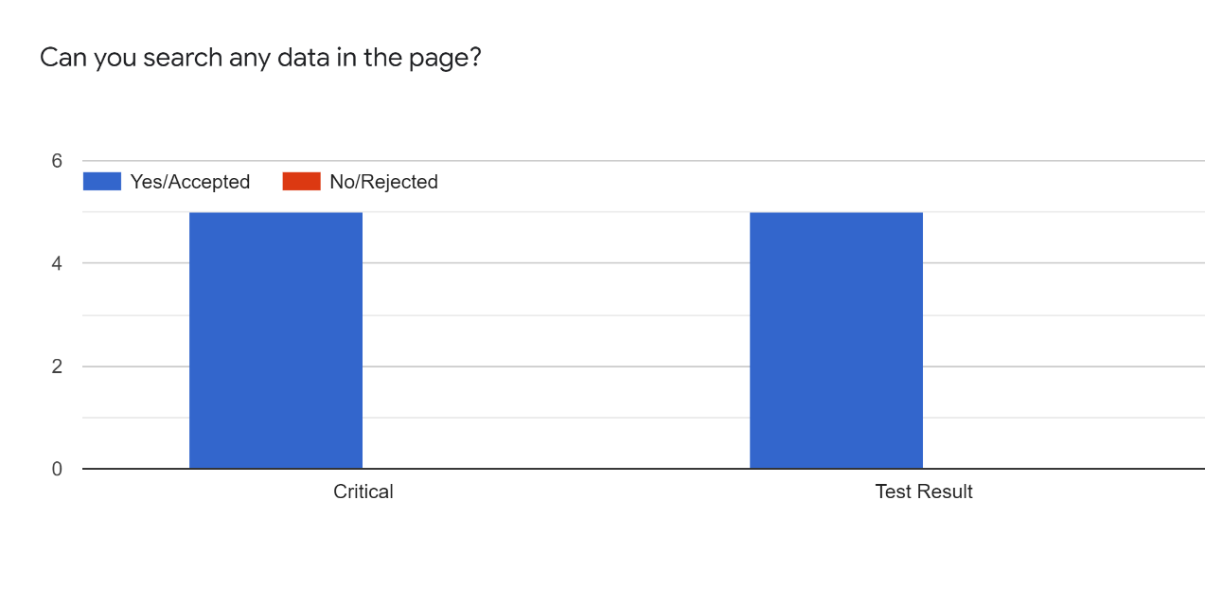

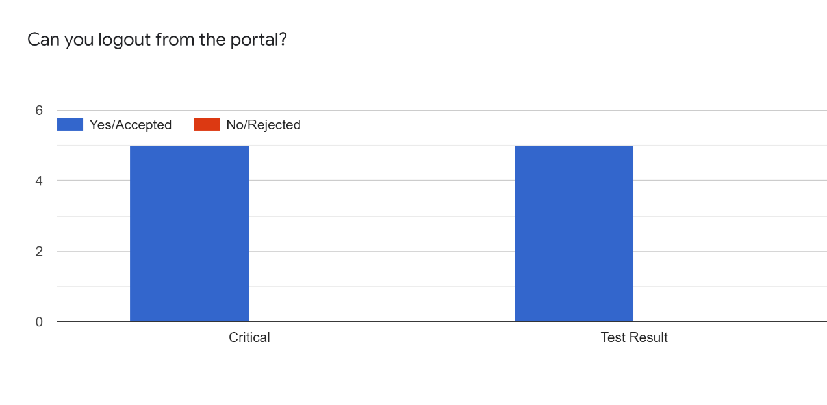

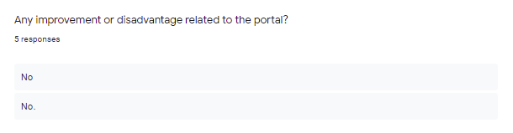

User Acceptance Test for New Intake

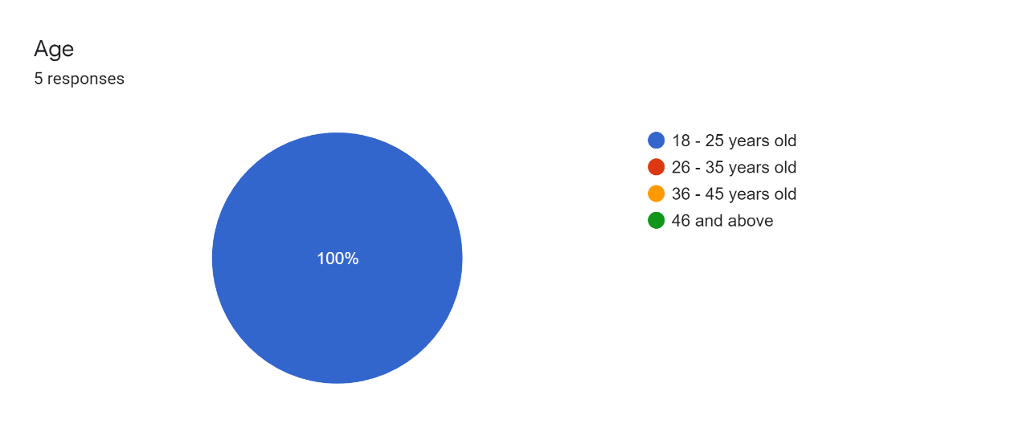

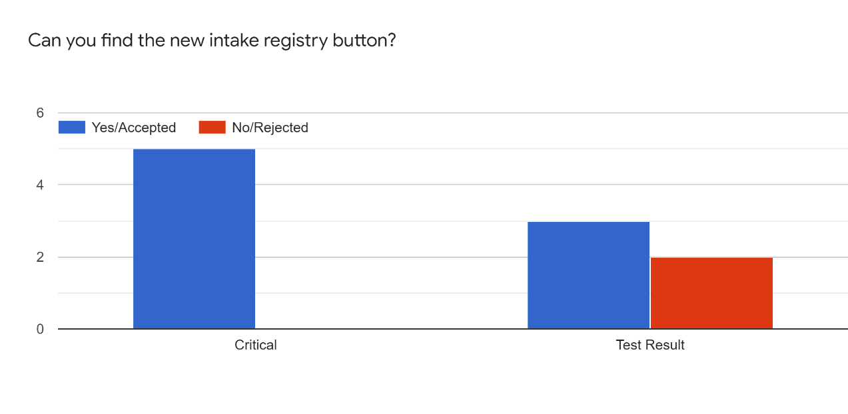

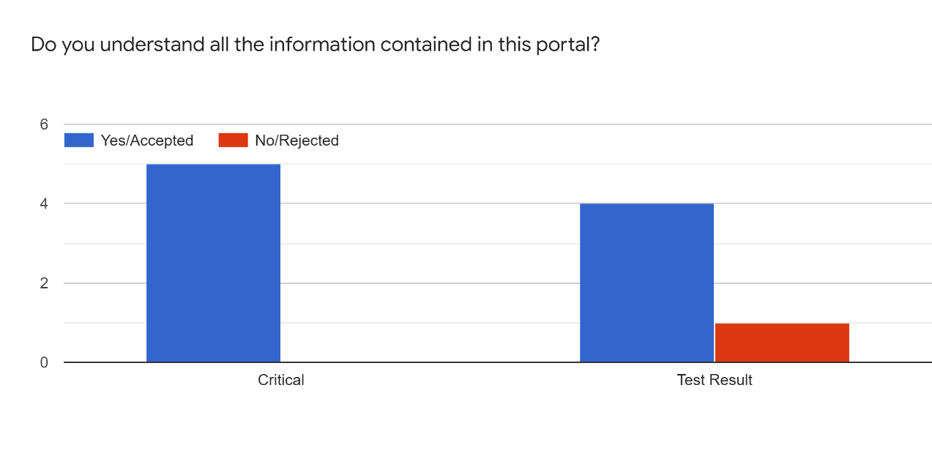

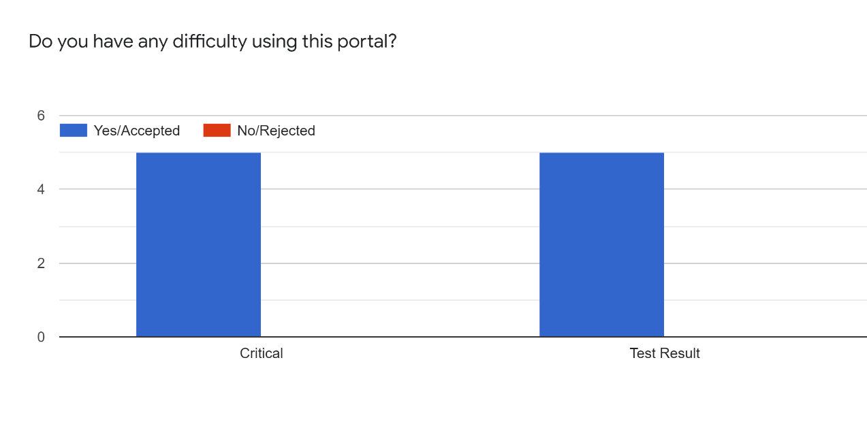



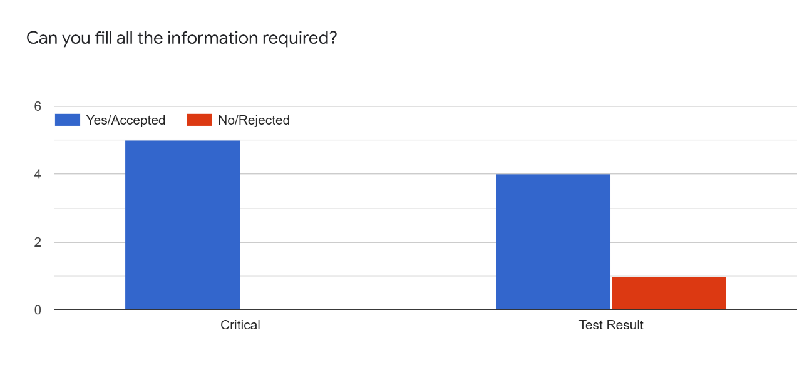



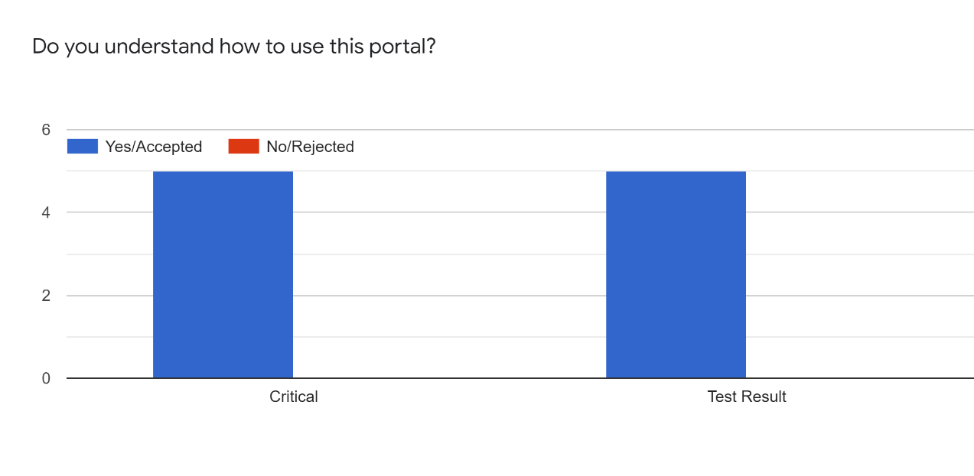

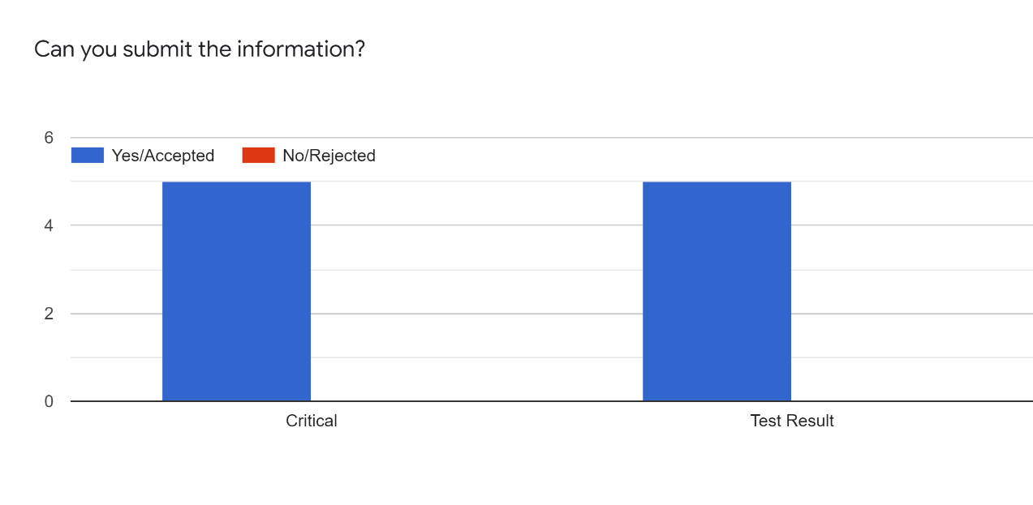

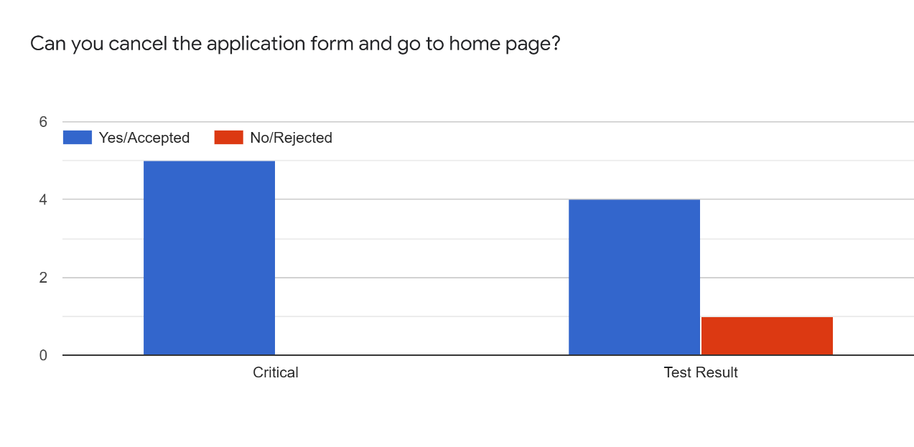

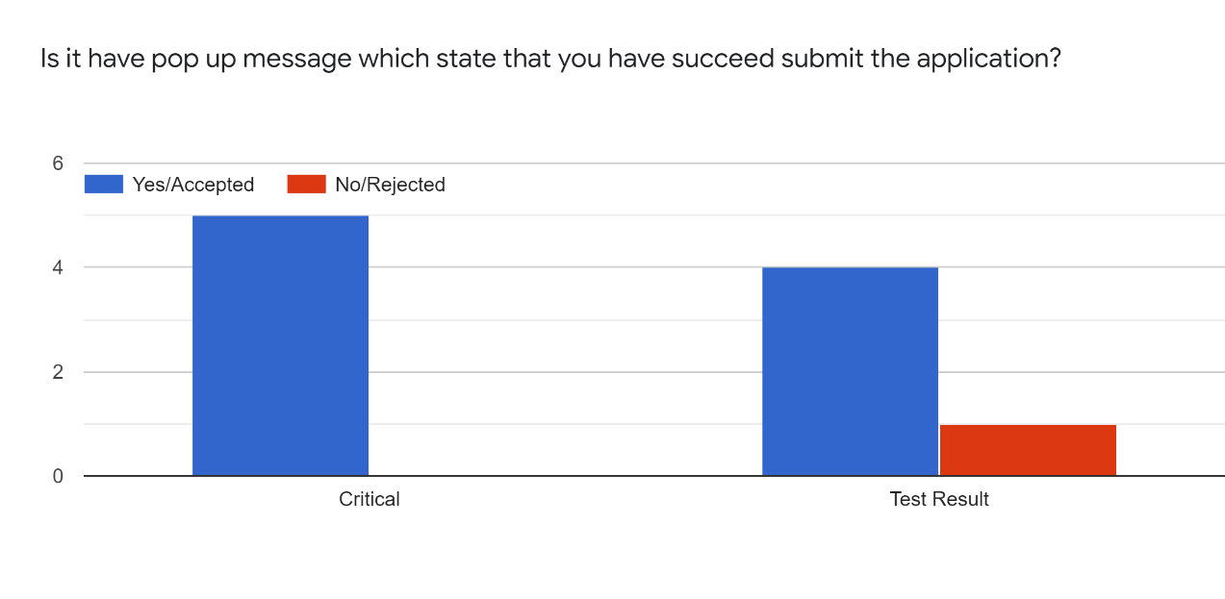

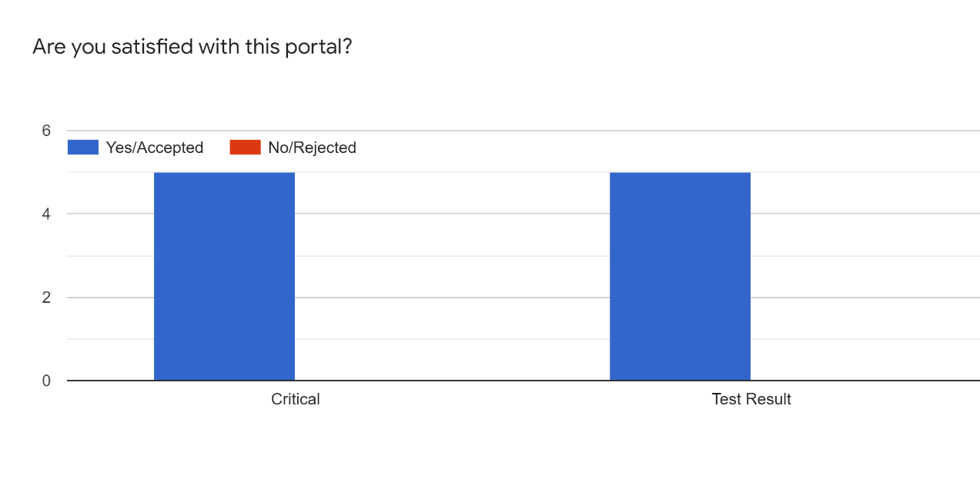

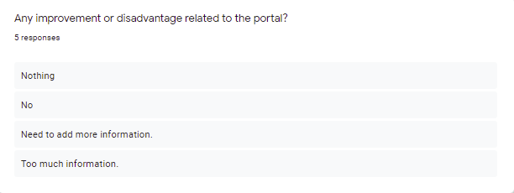

User Acceptance Test for Current Intake





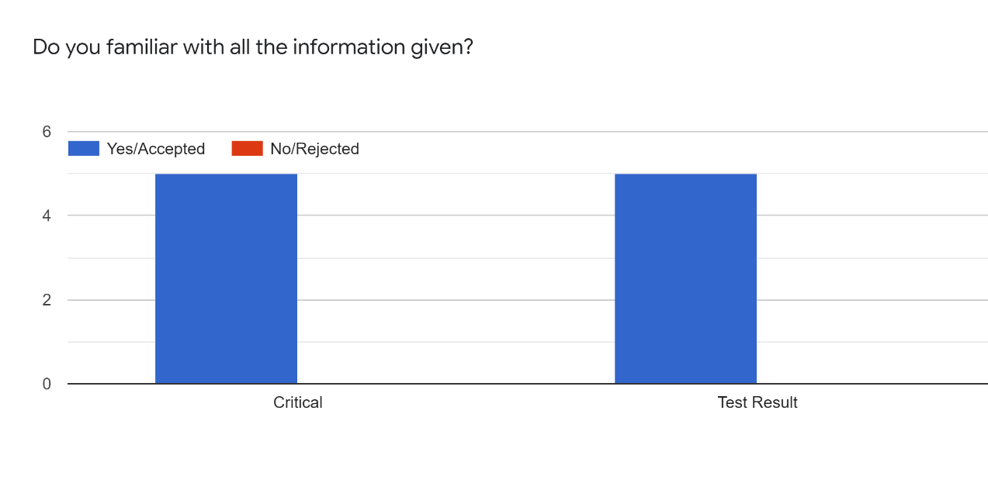

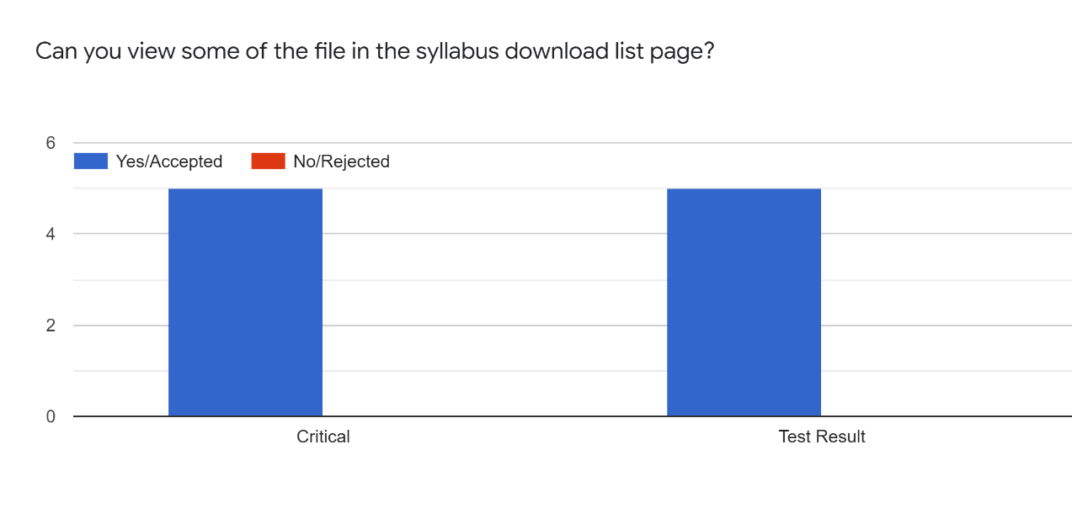

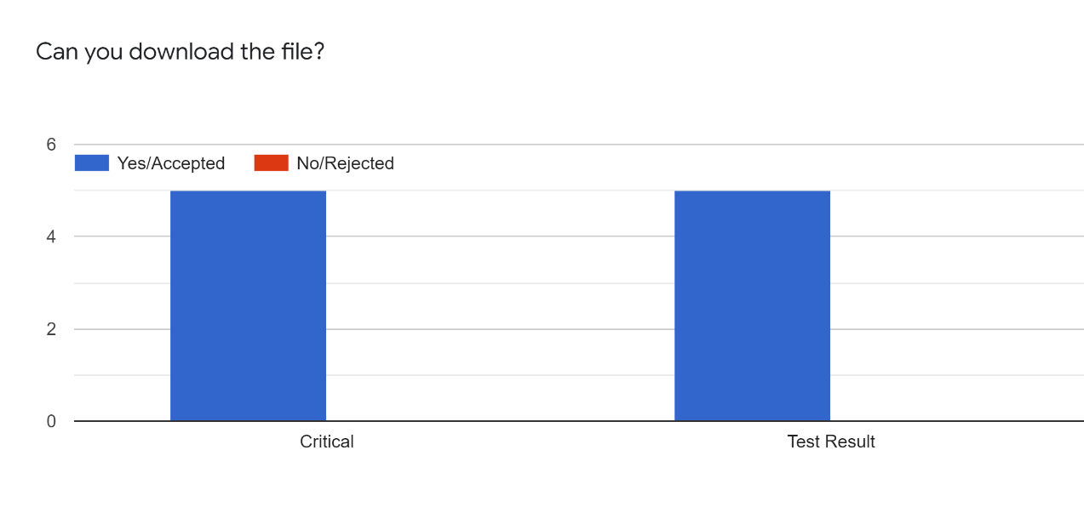

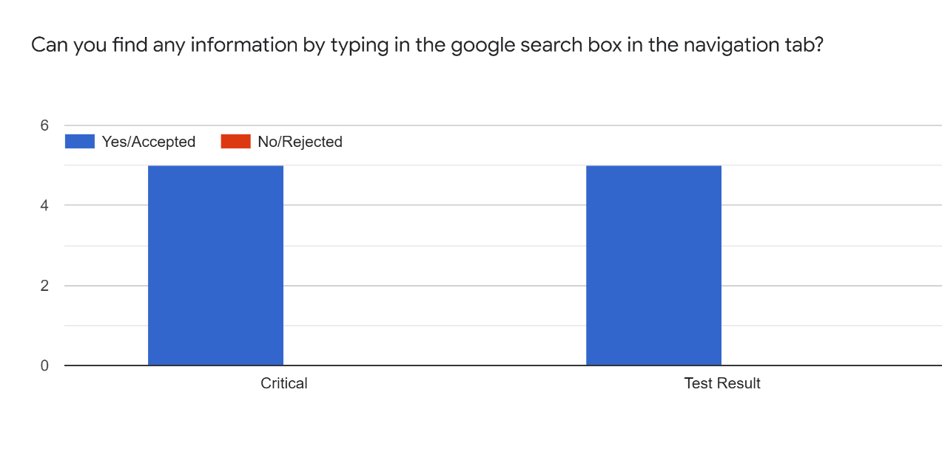

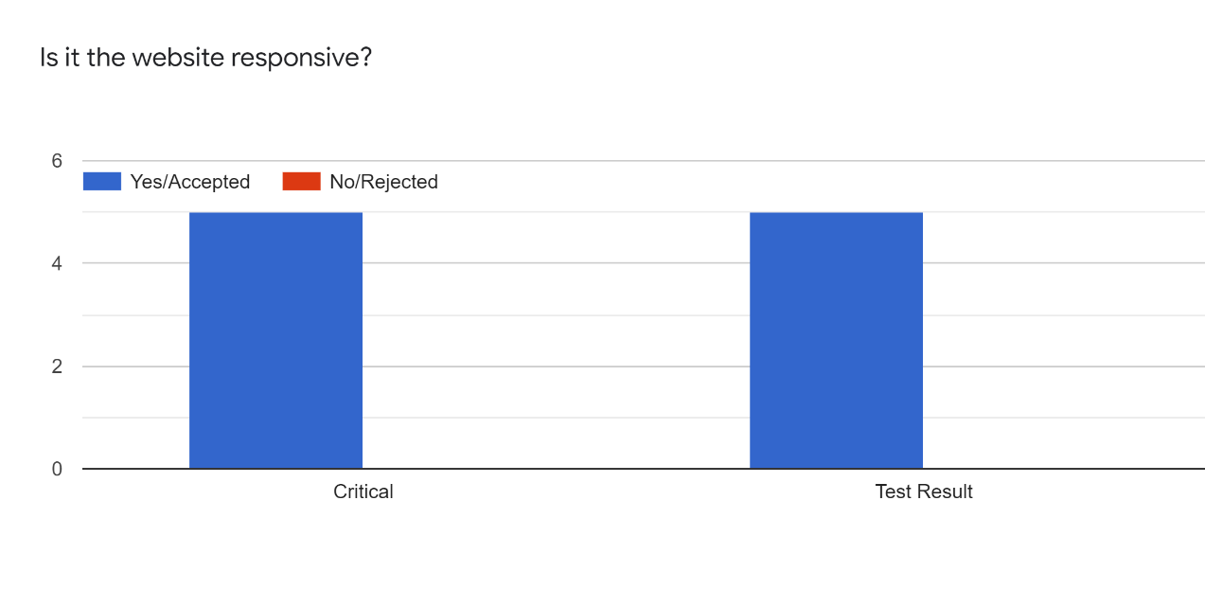

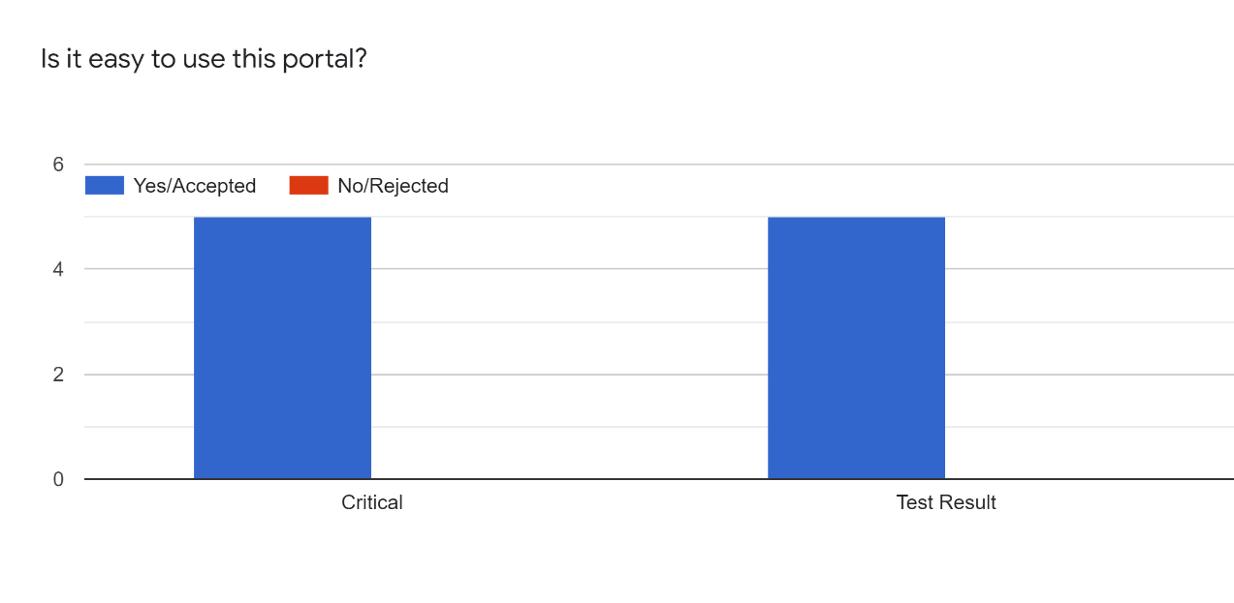

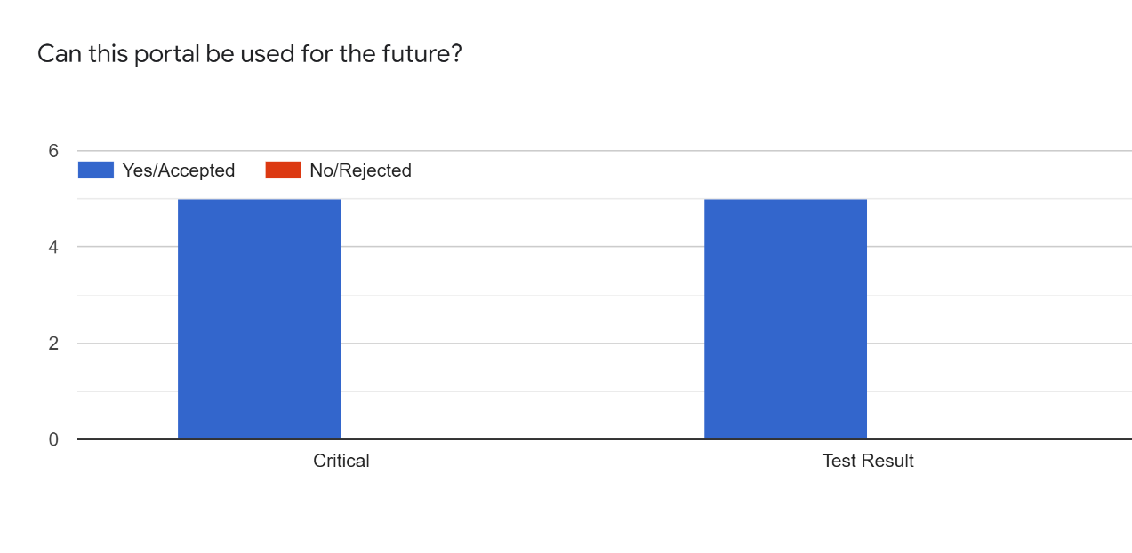





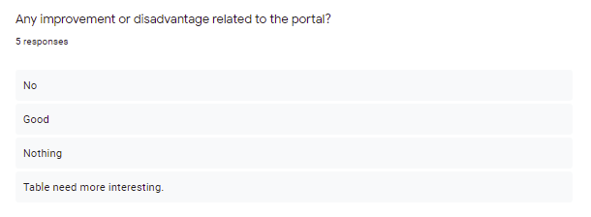

User Acceptance Test for Staff





